# Introduction to Artificial Intelligence (IAI)

Table of Contents

Introduction to Artificial Intelligence (IAI) 0

**Student declaration:** 0

INTRODUCTION 5

LITERATURE REVIEW 10

(A) Existing solutions: Research and discuss existing chatbot implementations in similar domains or related fields. 10

**Chatbot 1** 10

**Chatbot 2** 10

**Chatbot 3** 12

**Chatbot 4** 13

**Chatbot 5** 14

**Chatbot 6** 15

**Chatbot 7** 16

**Chatbot 8** 17

**Chatbot 9** 19

**Chatbot 10** 20

**Chatbot 11** 21

**Chatbot 12** 22

**Chatbot 13** 23

**Chatbot 14** 24

**Chatbot 15** 24

**Chatbot 16** 28

(B) Relevant theories and technologies: Review relevant theories and technologies related to chatbot development, such as natural language processing (NLP), artificial intelligence (AI), and knowledge representation techniques. 29

**1.** **Natural Language Processing (NLP)** 29

**2.** **Artificial Intelligence (AI)** 29

**3.** **Knowledge Representation** 30

**4.** **User-Centered Design** 32

**5.** **Integration and Interoperability** 32

(C) Gaps in current technology: Identify and discuss any gaps or limitations in existing solutions that you want your chatbot to address. 33

**1.** **Limited Personalization** 33

**2.** **Contextual Understanding** 33

**3.** **Response Consistency** 33

**4.** **Data Overload Management** 33

**5.** **User Engagement** 34

**6.** **Multilingual support** 34

METHODOLOGY 35

KNOWLEDGE REPRESENTATION TECHNIQUES: 38

TOOLS AND TECHNIQUES USED 39

DEVELOPMENT PROCESS: 41

1.Initial Design Phase 41

2. Design Phase 41

3. Development Phase 41

4. Testing Phase 42

5. Final Implementation 42

Frameworks and Methodologies Used 43

IMPLEMENTATION 44

Key Functions Implementation 44

CHALLENGES FACED 44

SOLUTIONS OF CHALLENGES 45

CONCLUSION 47

SUMMARY OF ACHIEVEMENTS 47

IMPACT OF THE CHATBOT 47

FUTURE WORK 48

FINAL THOUGHTS 48

REFRENCES: 49

Figure 1 Chatbot 2 Movie Guru (i) 11

Figure 2 Chatbot 2 Movie Guru (ii) 11

Figure 3 Chatbot 2 Movie Guru (iii) 12

Figure 4 Chatbot 3 FlixFinder (i) 13

Figure 5 Chatbot 3 FlixFinder (ii) 13

Figure 6 Chatbot 5 FlickPicks (i) 14

Figure 7 Chatbot 6 Movie Swiper (i) 16

Figure 8 Chatbot 7 Movie Matcher (i) 17

Figure 9 Chatbot 8 Movie Genie (i) 19

Figure 10 Chatbot 9 Netflix Discord Bot (i) 19

Figure 11 Chatbot 9 Netflix Discord Bot (ii) 20

Figure 12 Chatbot 9 Netflix Discord Bot (iii) 20

Figure 13 Chatbot 10 Cinebot (i) 21

Figure 14 Chatbot 11 FlickBot (i) 22

Figure 15 Chatbot 12 MovieBot (i) 23

Figure 16 Chatbot 12 Rotten Tomatoes Bot (i) 24

Figure 17 Chatbot 15 Easy-Peasy.AI (i) 26

Figure 18 Chatbot 15 Easy-Peasy.AI (ii) 27

Figure 19 Chatbot 16 Replika (i) 28

Figure 20 Detailed Semantic Key Diagram (i) 31

Figure 21 Workflow Flowchart 35

Figure 22 MovieMate 36

Figure 23 MovieMate(2) 37

Figure 24 Multi-lingual support 40

Figure 25 Chatgpt integration 45

Figure 26 Rules and constraints 46

# INTRODUCTION

**Purpose of the chatbot:** A movie recommendation chatbot's main goal is to improve customers' movie-watching experiences by offering them personalized movie recommendations based on their tastes. This chatbot analyses user inputs and suggests movies based on their viewing history, hobbies, and tastes using artificial intelligence (AI) and machine learning techniques​ (Qin & Zhang, 2021)​.

**Intended use case:**

1. **Personalised Movie Suggestions:**

To provide tailored movie recommendations, the chatbot examines user preferences, including preferred genres, actors, directors, and previously viewed films​ (Zhang, Lu, & Jin, 2020)​.

Example: A user can ask the chatbot to suggest action films like "The Dark Knight" and Jim Carrey comedies.

1. **Interactive Recommendation Process:**

Engage users in interactive dialogues to refine preferences and better understand their current mood or specific requirements ​(Ali, 2023)​.

Example: To customize recommendations, the chatbot might pose follow-up queries such as "Are you in the mood for something adventurous or something more relaxing?"

1. **Movie Details and Information:**

Offer in-depth facts on suggested films, such as trailer links, cast bios, IMDb or Rotten Tomatoes ratings, and storyline synopses.

Example: Before choosing to see a suggested film, users can browse reviews or inquire about the plot of the film.

1. **Streaming Availability and Options:**

To verify availability and offer direct links for streaming or renting, integrate with streaming services like Netflix, Hulu, or Amazon Prime.

Example: If a suggested film isn't available on the streaming service to which they have subscribed, the chatbot can let consumers know and provide some substitutes.

1. **Upcoming Releases and Movie News:**

To keep users informed and interested, provide updates on forthcoming film releases, celebrity news, and industry developments.

Example: Users can ask about the newest contenders for the Oscar season or about forthcoming superhero movies.

1. **User Engagement and Feedback:**

Gather user input to provide better suggestions over time and increase the chatbot's capacity to accommodate different preferences.

Example: Users may be asked by the chatbot to rate movies that are suggested or to share their movie-watching experiences.

1. **Integration Across Platforms:**

Seamlessly integrate with messaging apps, social media platforms, or dedicated movie websites to reach users wherever they prefer to interact ​(Panda & Kaur, 2023)​.

Example: To obtain recommendations, users can reach the chatbot directly on a website that reviews movies or through Facebook Messenger or WhatsApp.

**Need for the Project:** A movie chatbot is obviously needed to improve and expedite the movie-watching experience in the modern digital age, where consumers demand individualized experiences and there is a plethora of entertainment possibilities ​(Liu, Choi, & Liu, 2021)​. The requirements and difficulties that a movie chatbot can resolve are as follows:

1. **Personalised Recommendation:**

Challenge: It may be challenging for users to identify movies among all the choices that match with their tastes.

Solution: To make personalized recommendations, a movie chatbot can examine user tastes in terms of genres, actors, directors, and viewing history. Users can find movies they're likely to appreciate without spending too much time looking thanks to this tailored method.

1. **Information Accessibility:**

Challenge: It could be difficult for users to compile comprehensively movie information, such as reviews, cast bios, storyline synopses, and streaming availability.

Solution: The chatbot may give customers immediate access to comprehensive movie information, helping them in choosing what to watch next. It makes the task of compiling pertinent information in one location easier through the integration of data from numerous sources.

1. **Real-Time Interaction and Convenience:**

Challenge: There is a lack of real-time interaction and personalization in traditional movie figuring methods like browsing through streaming services or relying on static lists.

Solution: With the help of a chatbot, consumers can interact in real time and receive prompt advice and responses. This improves convenience by offering users fast accessibility to information and movie recommendations wherever they are and at any time.

1. **Engagement and User Satisfaction:**

Challenge: In the competitive entertainment sector, increasing customer happiness and engagement require innovative approaches that accommodate personal tastes.

Solution: The chatbot increases customer pleasure and fosters loyalty by connecting with users in real-time and modifying recommendations in response to their comments.

**Potential Benefits:**

* **Enhanced User Experience:** improves client satisfaction and engagement through providing detailed information and individualized movie suggestions.

* **Time Efficiency:** enables customers discover and watch movies that are personalized to their tastes more quickly, saving them time.

* **Convenience:** offers an effortless and user-friendly language interface for exploring movies on a variety of platforms and gadgets.

* **Improved Decision Making:** provides consumers the power to choose wisely when it involves movies by providing them with up-to-date and accurate information.

* **Promotion of Lesser-Known Content:** making it simpler to find unusual and new films, which encourages a wider variety of material and diversity in film viewership.

**Scope of the Chatbot:** The scope of a movie chatbot defines its functionalities and capabilities.

**Functionalities and Capabilities:**

1. **Personalised Movie Recommendation:**

* Consider the interests of the user (genres, actors, directors, etc.) and make customized movie recommendations.

* Improve suggestions using artificial intelligence techniques by considering viewing history and user input.

1. **Movie Information Retrieval:**

* Offers detailed movie information, such as trailers, actor and crew bios, genre descriptions, release dates, and ratings from a variety of websites (such as Rotten Tomatoes and IMDb).

* Offer viewers with an analysis of comparable movies based on their preferences.

1. **Real-Time Movie Availability:**

* Authenticate and inform users understand whether movies are accessible for either buying or renting on streaming services (such Netflix, Hulu, and Amazon Prime, among others).

* Offer alternatives or links directly so that people can watch or purchase movies.

1. **Interactive Dialogue and User Engagement:**

* Conduct interactive conversations with people to learn understand their preferred choices and modify suggestions.

* Provides conversation capabilities for quickly responding to inquiries, offer more details, and manage follow-up questions.

1. **Upcoming Releases and Movie News:**

* Advise users of approaching film updates, premieres, and news from the business.

* Offer information about recent box office accomplishments, award nominations, and celebrity news.

1. **Genre-Based Recommendations:**

* Provide movie recommendations based on subjects or genres, such drama, action, comedy, science fiction, etc.

* Give suggestions for lesser-known genres or categories to appeal to niche tastes.

1. **User Interaction and Feedback Collection:**

* Gather reviews, ratings, and comments from users about movies that are recommended.

* Analyse user input to improve the user experience and inform future recommendations.

1. **Integration with External Platforms:**

* Link easily with websites, mobile apps, and messaging services like Facebook Messenger and WhatsApp.

* Assure that users get an identical encounter on every platform and gadgets.

1. **Multi-Language and Multi-Region Support:**

* Offer multilingual support for assisting a wide range of users.

* Consider about regional preferences and the availability of films in different nations or areas.

1. **Data Security and Privacy:**

* Guarantee that user data, preferences, and interactions are processed with data security and privacy compliance in mind.

* Have policies in place that protect user information and maintain confidentiality.

1. **Accessibility Features:**

* Include accessible elements like text-to-speech functionality and assistance for those with visual impairments.

* Ensure that the chatbot's UI is easy to use as well as compatible with plenty of gadgets and assistive technologies.

**Overview of the report:** The research project describes the creation and deployment of a working movie chatbot with the objective to improve the user experience by providing accurate and relevant information. It includes comprehensive documentation such as:

Introduction: Defines the main objective of the chatbot, why it's required in the context of retrieving movie-related information, and the range of features it offers.

Reviews pertinent concepts (such NLP and AI) and identifies gaps in technology that the chatbot seeks to fill. It also discusses contemporary chatbot implementations in related domains.

Methodology: Defines the technologies and instruments utilized in development, the design strategy, the selection of knowledge representation techniques (such as semantic networks), and the entire development process.

Implementation: Emphasizes significant components that have been implemented to improve user experience while highlighting difficulties encountered (such as natural language understanding and integration difficulties) and related remedies.

Conclusion: Highlights successes, talks about how the chatbot might affect the way people learn about movies, suggests topics for further research and development, and considers lessons learned from the project that could be used to other chatbot projects in the future.

# LITERATURE REVIEW

## Existing solutions: Research and discuss existing chatbot implementations in similar domains or related fields.

|  |  |
| --- | --- |
| **Chatbot 1** | |
| Chatbot name | CinephileBot (Cinephile-Movie-Bot/README.md at Main · MSarm-DSML/Cinephile-Movie-Bot, n.d.) |
| Purpose and functionality | CinephileBot is a Telegram bot that delivers movie recommendations and extensive information according to user choices. Users can specify their picks for genres, actors, or directors to obtain personalized movie recommendations. |
| Technology used | CinephileBot employs a state-of-the-art Language Model (LLM) technology to be paired with data gathered by IMDb to deliver precise and pertinent recommendations and comprehensive movie information. |
| Advantages | CinephileBot generates highly accurate movie recommendations and contains a vast database of films, encompassing cast and crew. |
| Disadvantages | CinephileBot is restricted to the data available on IMDb, with occasional delays while fetching data during peak demand periods. |
| Similarities with MovieMate | CinephileBot and MovieMate deliver personalized movie recommendations and meticulous movie information. |
| Differences with MovieMate | CinephileBot utilizes a bespoke LLM engine and IMDb data, whereas MovieMate utilizes ChatGPT for broader data sourcing and NLP capabilities. |

|  |  |
| --- | --- |
| **Chatbot 2** | |
| Chatbot name | Movie Guru (Movie Guru, n.d.) |
| Purpose and functionality | Movie Guru suggests films depending on the user's mood and genre preferences, using Dialogflow and the TMDb API for mood-based suggestions. The clients can describe their emotions for example happy, adventurous, or funny, and receive suggestions that match clients’ moods. |
| Technology used | Movie Guru is powered by Dialogflow and integrates with the TMDb API for real-time data retrieval and mood-based suggestions. |
| Advantages | Movie Guru features unique mood-based suggestions and integrates seamlessly with the TMDb API for up-to-date information. |
| Disadvantages | Movie Guru is dependable on the TMDb API’s availability of performance and rate restrictions. |
| Similarities with MovieMate | Movie Guru and MovieMate offer customized movie suggestions. |
| Differences with MovieMate | Movie Guru focuses on mood-based suggestions, while MovieMate offers a broader preference of options and detailed movie information. |

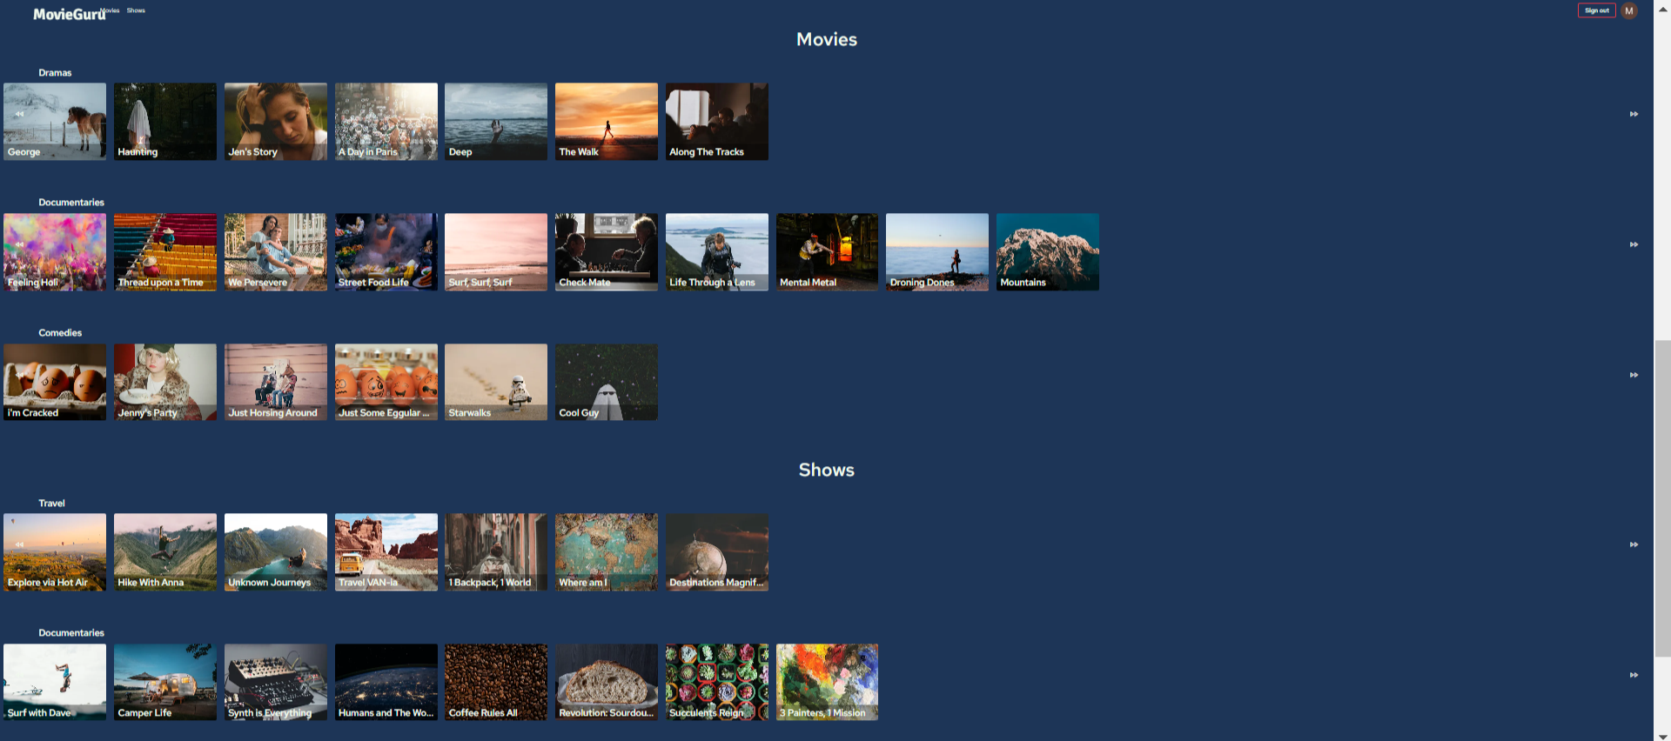

Figure Chatbot 2 Movie Guru (i)

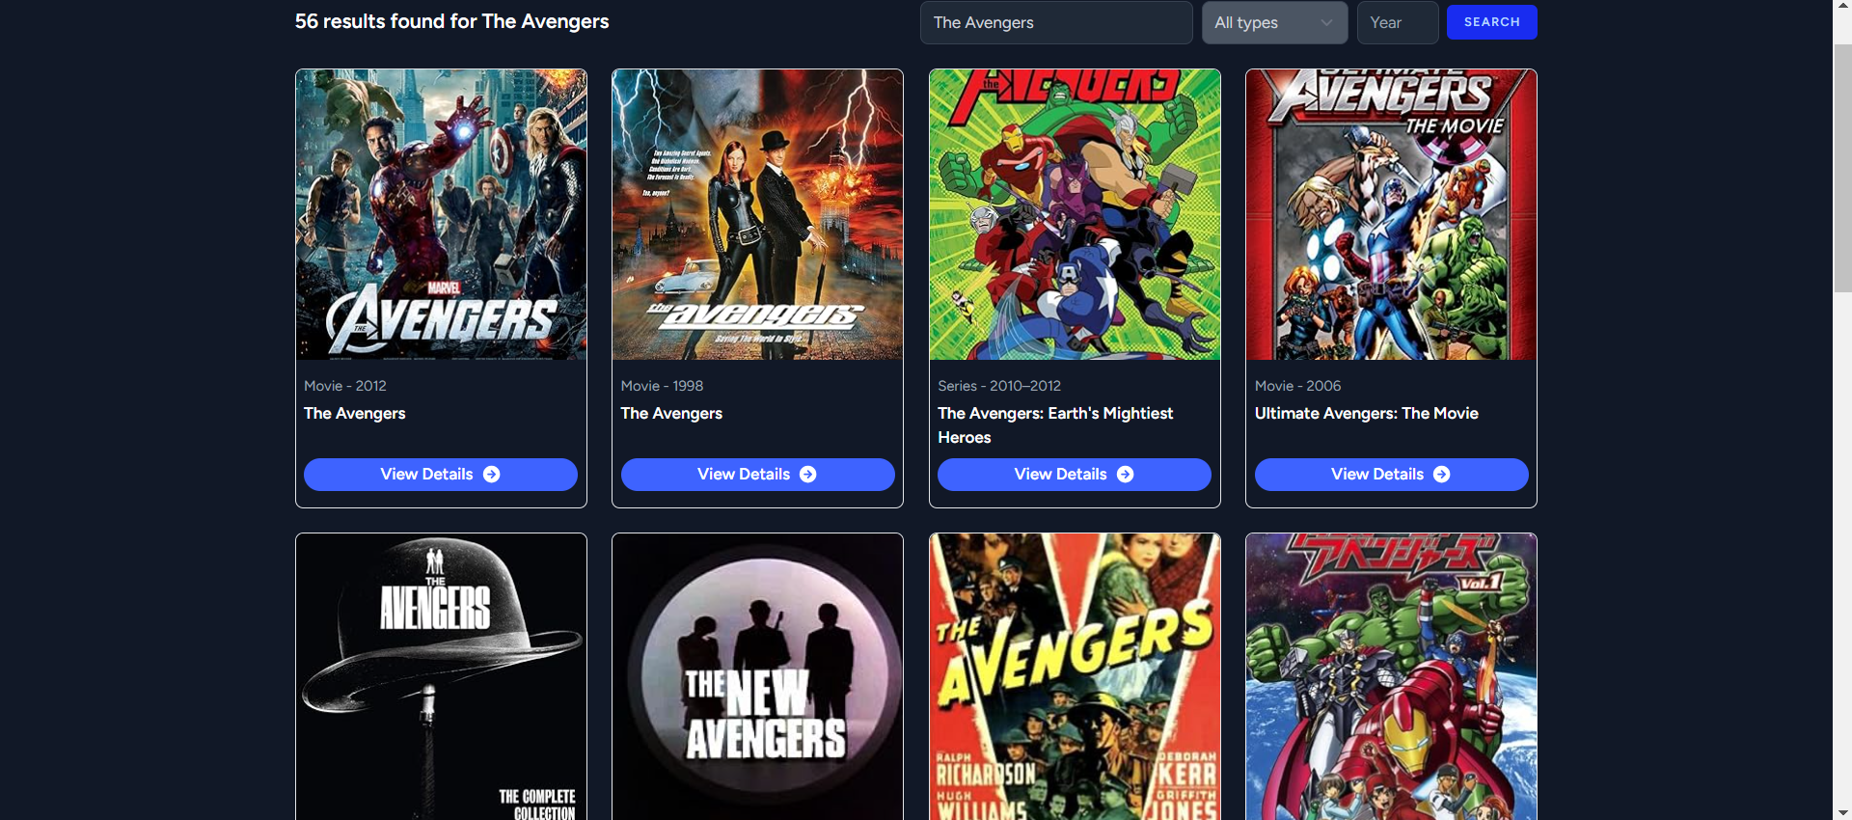

Figure Chatbot 2 Movie Guru (ii)

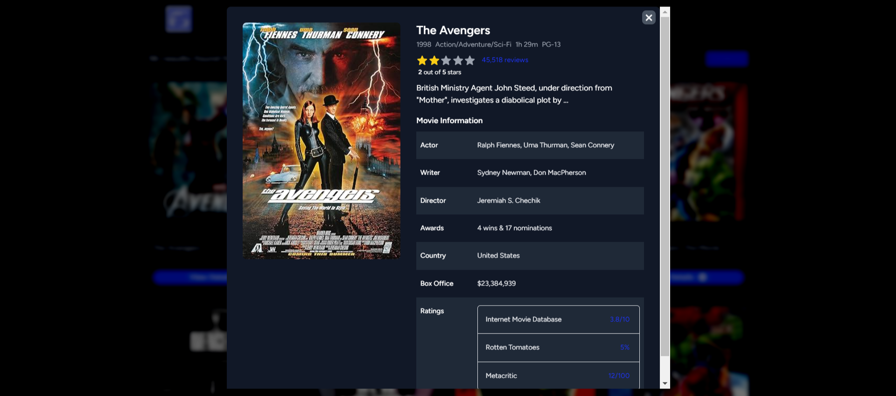

Figure Chatbot 2 Movie Guru (iii)

|  |  |
| --- | --- |
| **Chatbot 3** | |
| Chatbot name | FlixFinder (:: Flixfinder ::, n.d.). |
| Purpose and functionality | FlixFinder assists clients in browsing for movies on streaming platforms by leveraging the Microsoft Bot Framework and streaming service APIs for current time availability. |
| Technology used | FlixFinder exploited Microsoft Bot Framework and integrated streaming service APIs for real-time streaming alternatives. |
| Advantages | FlixFinder directs users to available streaming alternatives and guarantees that streaming availability remains contemporary. |
| Disadvantages | FlixFinder is constrained by the streaming services covered by the APIs. |
| Similarities with MovieMate | FlixFinder and MovieMate permit clients to find movies to watch. |
| Differences with MovieMate | FlixFinder emphasizes streaming alternatives, whilst MovieMate provides accurate recommendations for movies and data. |

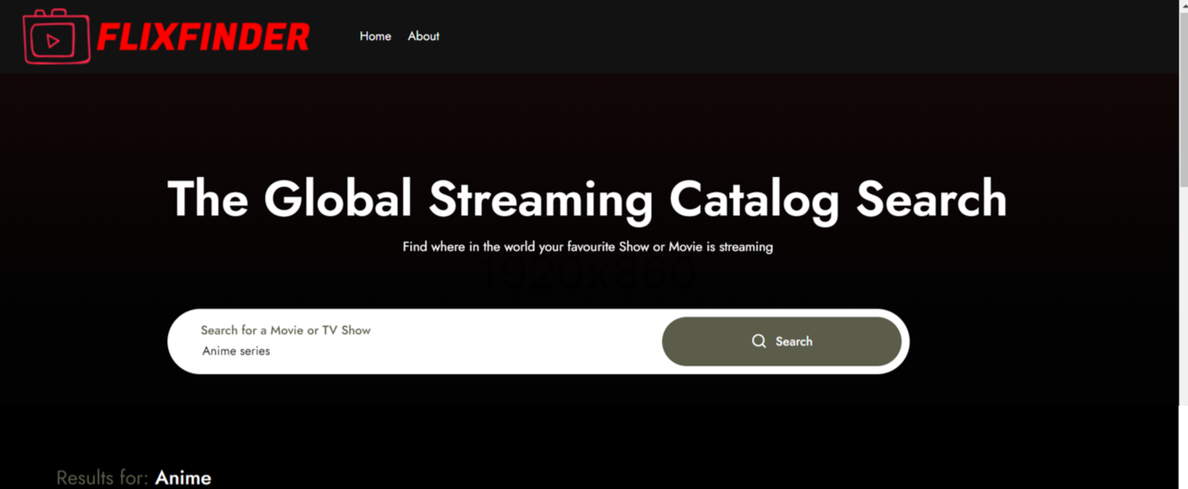

Figure Chatbot 3 FlixFinder (i)

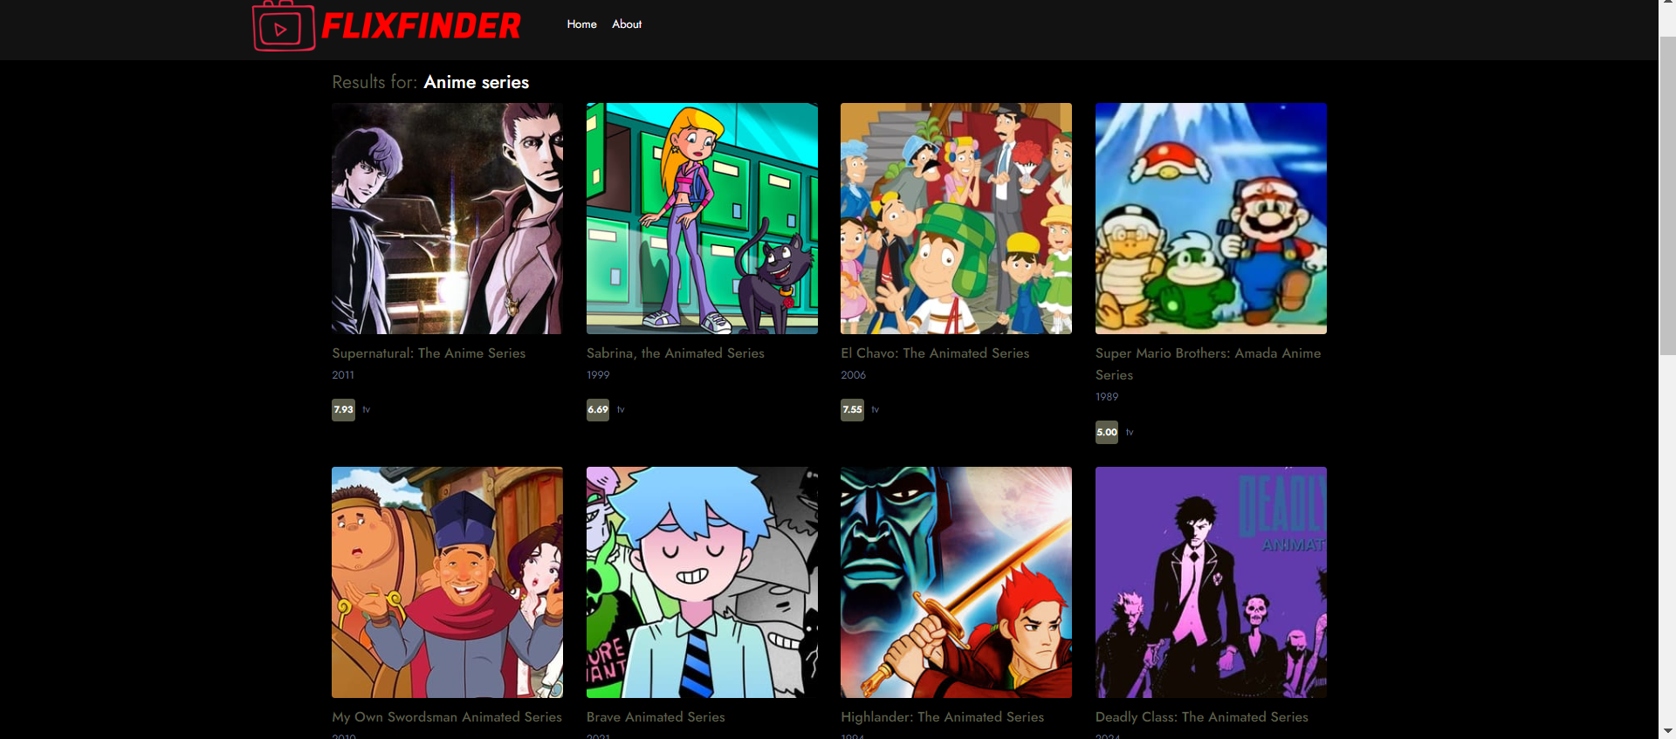

Figure Chatbot 3 FlixFinder (ii)

|  |  |
| --- | --- |
| **Chatbot 4** | |
| Chatbot name | ReelSuggest (Satwik, n.d.) |
| Purpose and functionality | ReelSuggest generates movie recommendations based on user reviews and ratings from Rotten Tomatoes, blending Rasa and Rotten Tomatoes data. |
| Technology used | ReelSuggest is built on Rasa but implements data sourced from Rotten Tomatoes for tailored proposals. (Satwik, n.d.) |
| Advantages | ReelSuggest exploits user reviews to produce top-accuracy proposals and relies on real user ratings to ensure preciseness. |
| Disadvantages | ReelSuggest is limited to Rotten Tomatoes data and contains potentially biased user reviews. |
| Similarities with MovieMate | ReelSuggest and MovieMate provide personalized movie recommendations. |
| Differences with MovieMate | ReelSuggest provides recommendations based on user reviews, on the other hand, MovieMate provides an array of recommendations relying on a ChatGPT dataset. |

|  |  |
| --- | --- |
| **Chatbot 5** | |
| Chatbot name | FlickPicks (LcsMilhan, n.d.) |
| Purpose and functionality | FlickPicks proposes films that correspond to trending and popular options discovered through social media analysis, with dynamic predictions powered by IBM Watson. |
| Technology used | FlickPicks employs IBM Watson and social media analysis of trends to present updated movie suggestions. |
| Advantages | FlickPicks produces dynamic suggestions based on existing film trends and social media data. |
| Disadvantages | FlickPicks suggestions can vary frequently due to trends that are incompatible with every user. |
| Similarities with MovieMate | FlickPicks and MovieMate provide movie suggestions. |
| Differences with MovieMate | FlickPicks focuses on trendy films, however, MovieMate provides consistent, preference-based suggestions. |

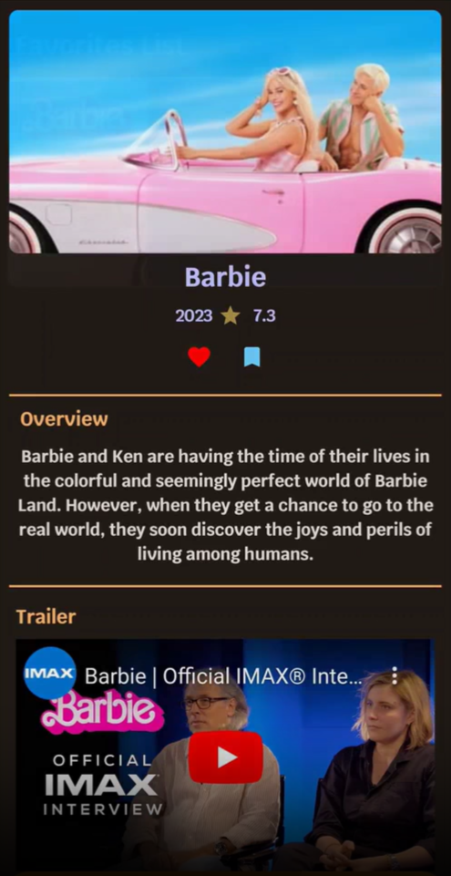

Figure Chatbot 5 FlickPicks (i)

|  |  |
| --- | --- |
| **Chatbot 6** | |
| Chatbot name | Movie Swiper. (Movie Swiper - Discord Bots, n.d.) |
| Purpose and functionality | MovieSwiper is a Discord bot that aids users browse films by swiping through choices. The user may like or dislike films, and the bot makes tuned recommendations that depend on their interactions. MovieSwiper is a fun and engaging chatbot that assists users in exploring new films and provides tailored movie recommendations that adapt to their interests over time. |
| Technology used | Movie Swiper integrates natural language processing (NLP) and machine learning methods to understand user preferences better and generate recommendations. It is integrated with Discord's API, facilitating seamless platform communication. The bot also retrieves movie data from various APIs such as The Movie Database (TMDb) to provide comprehensive data on each film. |
| Advantages | The swipe-based interface makes searching for films more entertaining and pleasurable. The bot learns from user interactions and generates more precise suggestions. Users can obtain movie suggestions without leaving the Discord chat platform. |
| Disadvantages | It is only accessible to Discord members who are active on the platform. The quality of recommendations is determined by external API data, which is often limited or erroneous. |
| Similarities with MovieMate | Both bots adjust movie suggestions based on user preferences. They both use natural language processing to efficiently understand and respond to user input. Both offer thorough information about recommended films. |
| Differences with MovieMate | Movie Swiper is a Discord bot, whereas MovieMate can be used across several platforms. Movie Swiper's interface is swipe-based, which makes it more interactive than MovieMate's text-based interaction. MovieMate may include larger functions such as extensive movie content and trailer links, whereas Movie Swiper prioritizes discovery by swiping. |

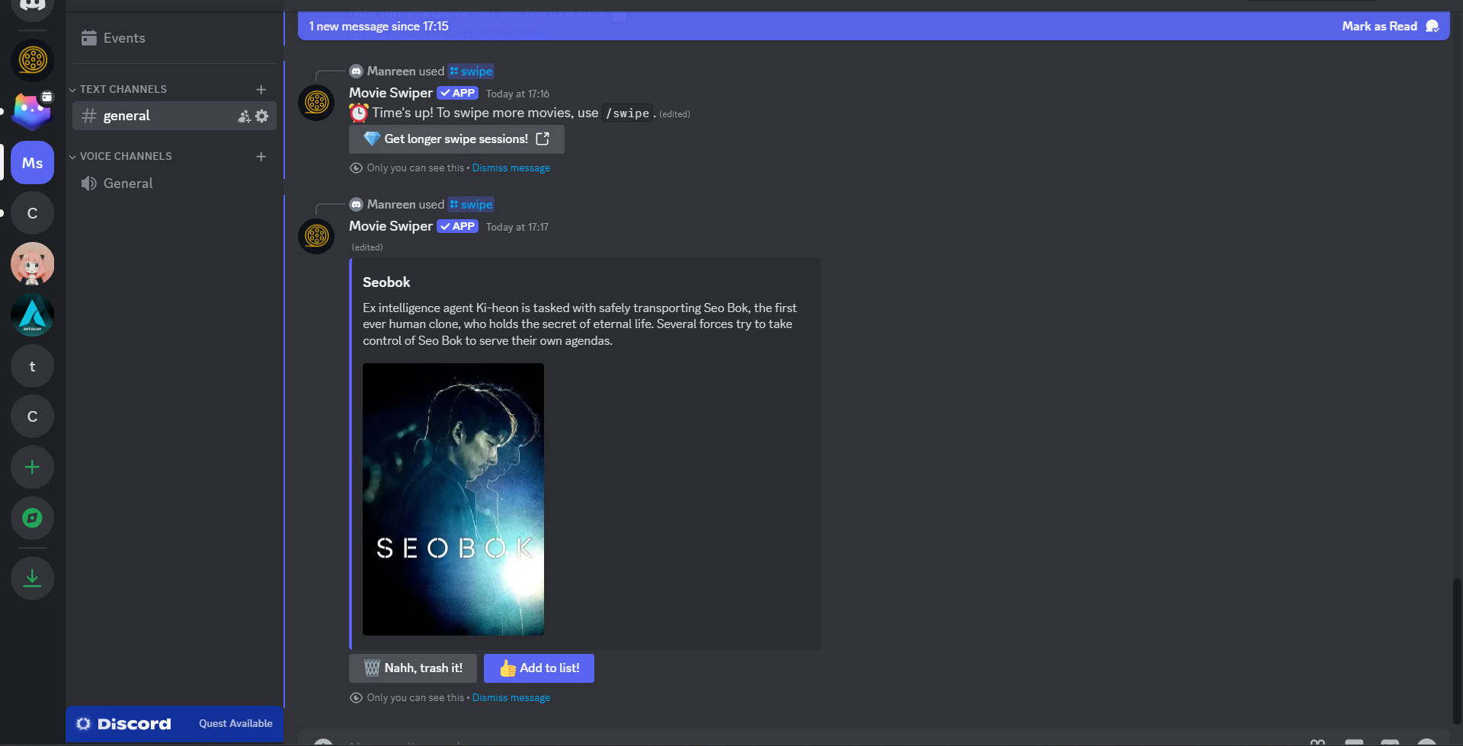

Figure Chatbot 6 Movie Swiper (i)

|  |  |
| --- | --- |
| **Chatbot 7** | |
| Chatbot name | MovieMatcher (Walker, R. D., 2024) |
| Purpose and functionality | MovieMatcher matches films according to the client’s moods and activities by using Google Dialogflow and sentiment analysis to produce personalized suggestions. |
| Technology used | MovieMatcher utilizes Google Dialogflow and sentiment analysis to produce personalized suggestions. |
| Advantages | MovieMatcher produces personalized suggestions depending on the client’s moods and activities. |
| Disadvantages | MovieMatcher client’s mood detection may differ, influencing the relevancy of suggestions. |
| Similarities with MovieMate | MovieMatcher and MovieMate produce personalized suggestions. |
| Differences with MovieMate | MovieMatcher addresses the client’s moods and activities, while MovieMate produces more general preferences-based choices. |

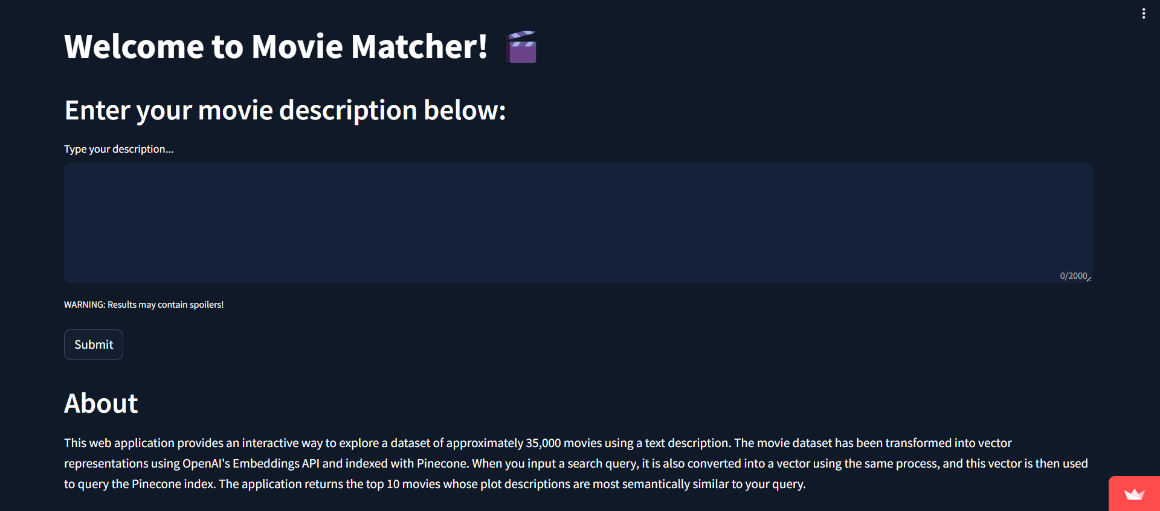

Figure Chatbot 7 Movie Matcher (i)

|  |  |
| --- | --- |
| **Chatbot 8** | |
| Chatbot name | MovieGenie (MovieGenie, 2024) |
| Purpose and functionality | MovieGenie provides highly customizable movie suggestions determined by user parameters and employing Microsoft Azure Bot Service and proprietary algorithms. |
| Technology used | MovieGenie makes customized suggestions employing Microsoft Azure Bot Service and proprietary algorithms. |
| Advantages | MovieGenie provides highly customizable selections that meet key user requirements. |
| Disadvantages | MovieGenie's intricacy in setting up precise criteria may pose challenges for some users. |
| Similarities with MovieMate | MovieGenie and MovieMate offer personalized movie suggestions. |
| Differences with MovieMate | MovieGenie has more customizable options, but MovieMate prioritizes simplicity and broader preference inputs. |

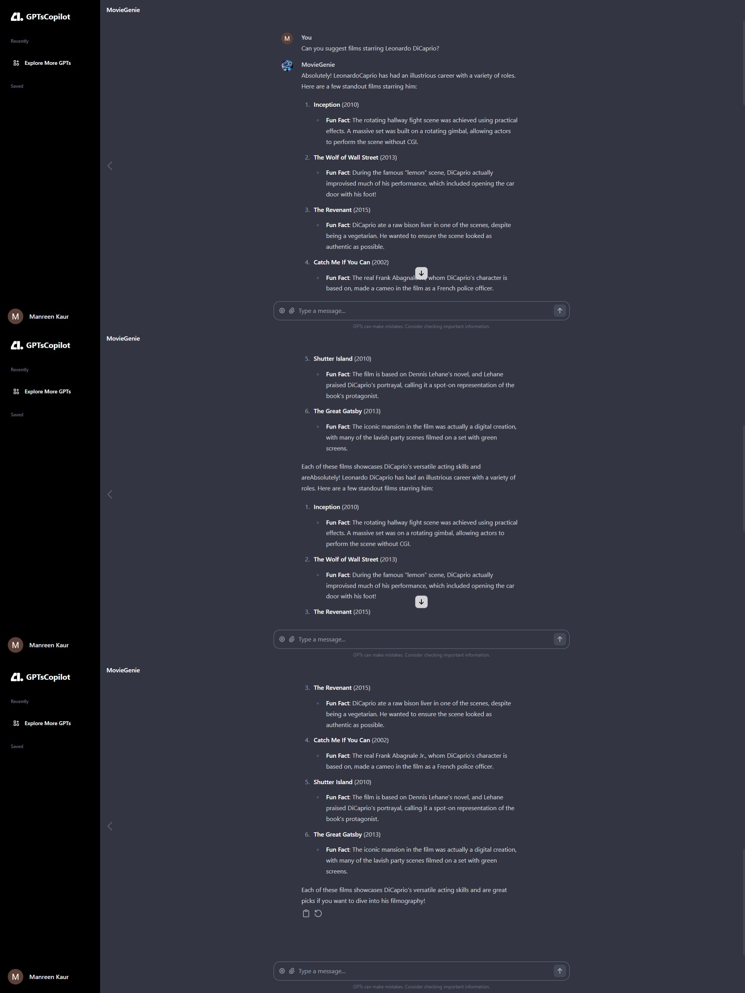

Figure Chatbot 8 Movie Genie (i)

|  |  |
| --- | --- |
| **Chatbot 9** | |
| Chatbot name | Netflix Discord Bot (Anmol., 2022) |
| Purpose and functionality | Netflix Discord Bot promotes Netflix episodes and films to suit the user's preferences. Furthermore, Netflix Bot serves recommendations, trailers, and information about Netflix content. |
| Technology used | Netflix Discord Bot combines proprietary AI and natural language processing to provide personalized recommendations. |
| Advantages | Netflix Discord Bot features an immense Netflix collection and personalized recommendations. |
| Disadvantages | Netflix Discord Bot is restricted to Netflix material, narrowing the range of recommendations. |
| Similarities with MovieMate | Netflix Discord Bot and MovieMate focus on personalized movie and TV show recommendations. |
| Differences with MovieMate | Netflix Discord Bot is restricted to Netflix content nevertheless MovieMate offers a wider range of movie recommendations. |

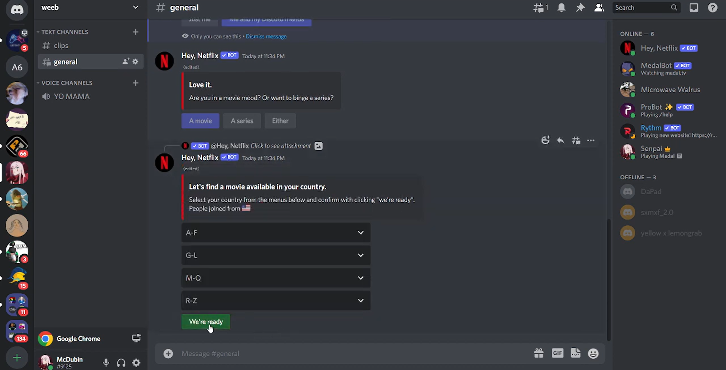

Figure Chatbot 9 Netflix Discord Bot (i)

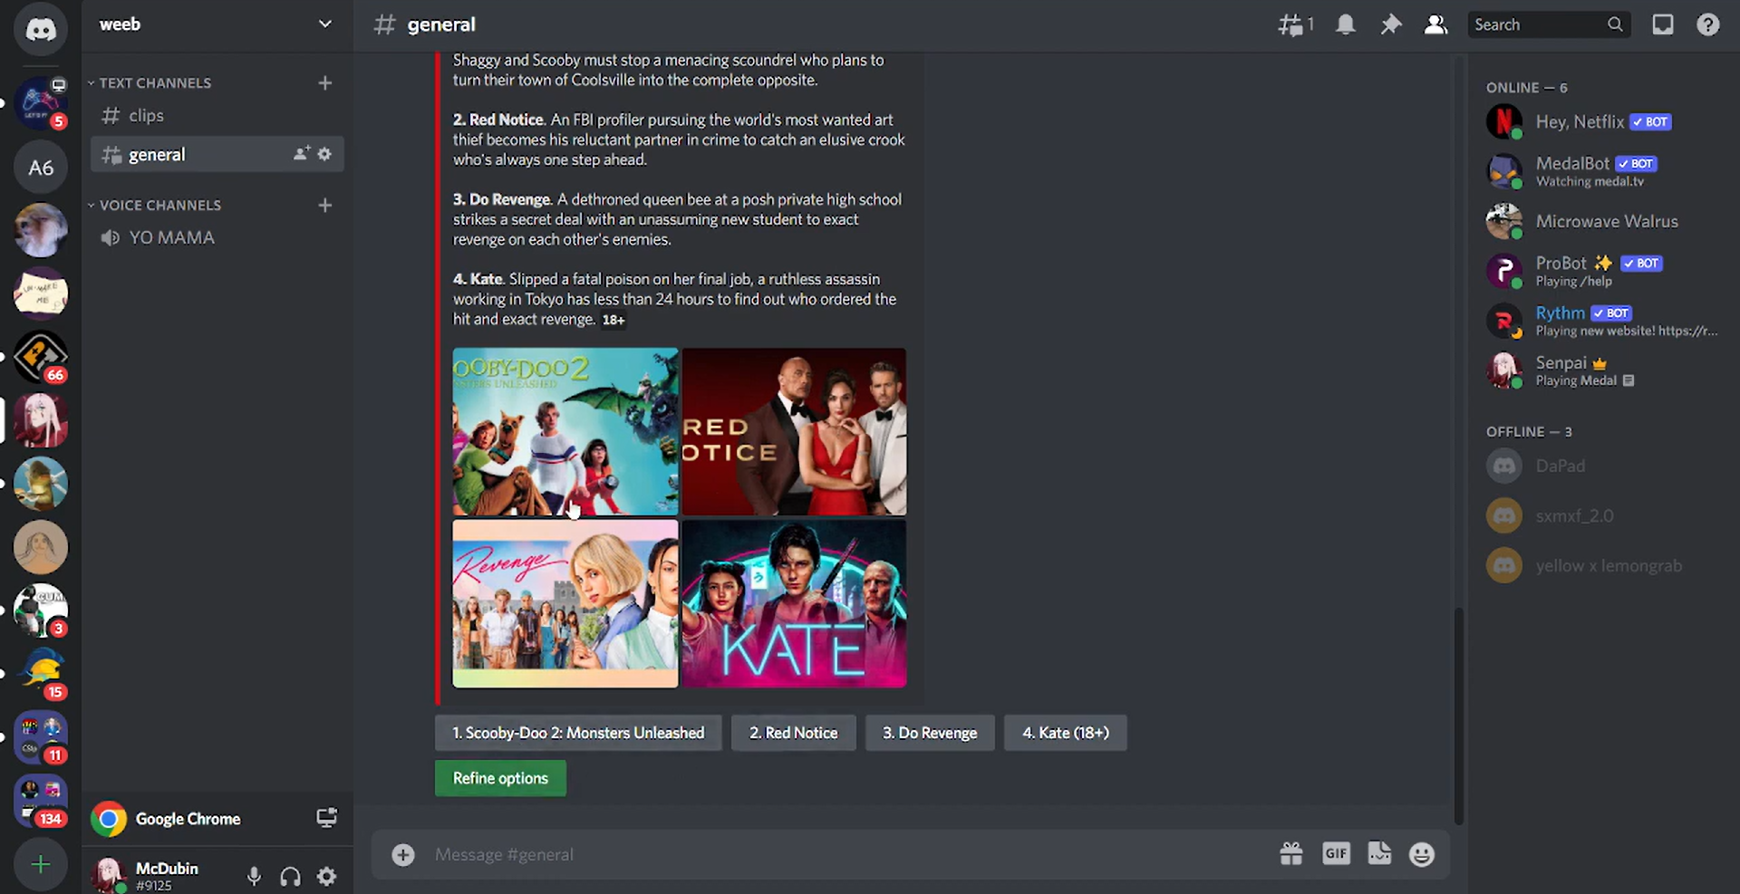

Figure Chatbot 9 Netflix Discord Bot (ii)

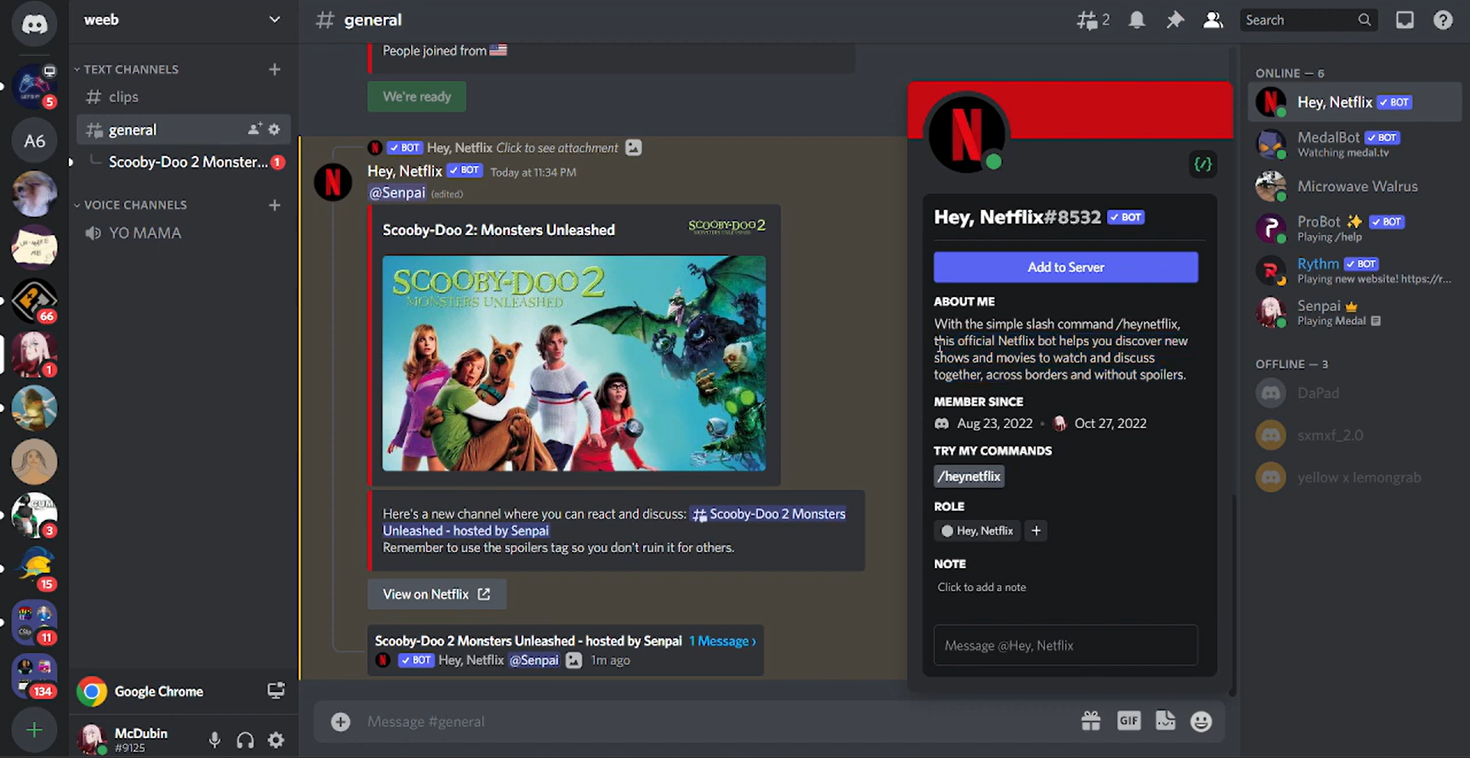

Figure Chatbot 9 Netflix Discord Bot (iii)

|  |  |
| --- | --- |
| **Chatbot 10** | |
| Chatbot name | Cinebot. (Cinebot., n.d.) |
| Purpose and functionality | Cinebot gives movies and trailers recommendations based solely on user preferences that focus exclusively on movies. |
| Technology used | Cinebot employs ChatGPT, AI, and NLP technologies to give personalized suggestions. |
| Advantages | Cinebot specializes in film and trailer recommendations. |
| Disadvantages | Cinebot is limited to movie suggestions and does not include TV show suggestions. |
| Similarities with MovieMate | Cinebot and MovieMate focused on movie recommendations. |
| Differences with MovieMate | Cinebot specializes in films without TV show recommendations, while MovieMate offers a broader scope. |

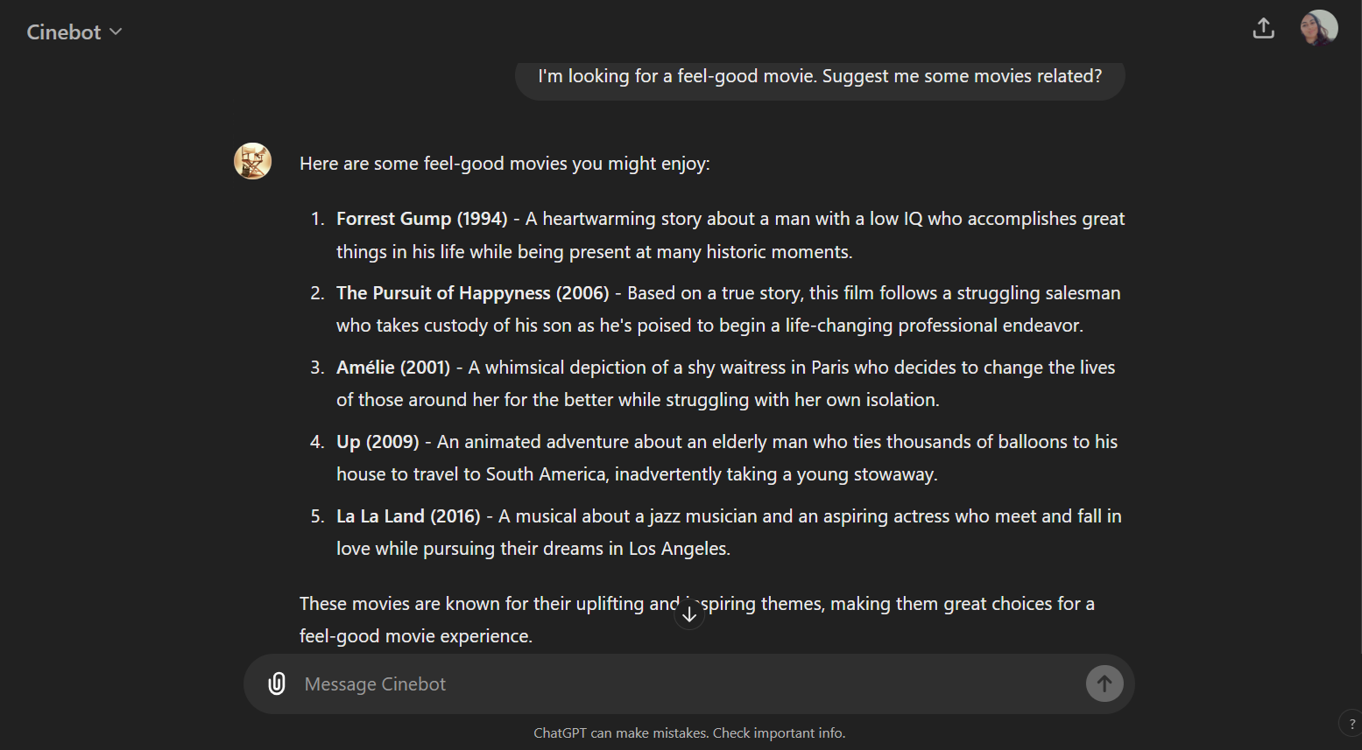

Figure Chatbot 10 Cinebot (i)

|  |  |
| --- | --- |
| **Chatbot 11** | |
| Chatbot name | FlickBot. (Jeremygrace, n.d.) |
| Purpose and functionality | FlickBot suggests movies determined by user input, including tailored suggestions, movie details, and trailers. (Popularity & Trending., n.d.) |
| Technology used | FlickBot employs AI, and NLP technologies to generate suggestions. (Jeremygrace, n.d.) |
| Advantages | FlickBot has personalized recommendations tailored to user preferences. (Popularity & Trending., n.d.) |
| Disadvantages | FlickBot has limited data sources that may hinder variety and accurate suggestions. (Jeremygrace, n.d.) |
| Similarities with MovieMate | FlickBot and MovieMate concentrate on movie recommendations and offer thorough information and trailers. (Jeremygrace, n.d.) |
| Differences with MovieMate | FlickBot’s functionality and scope are like MovieMate, with a focus on movie recommendations and details. (Jeremygrace, n.d.) |

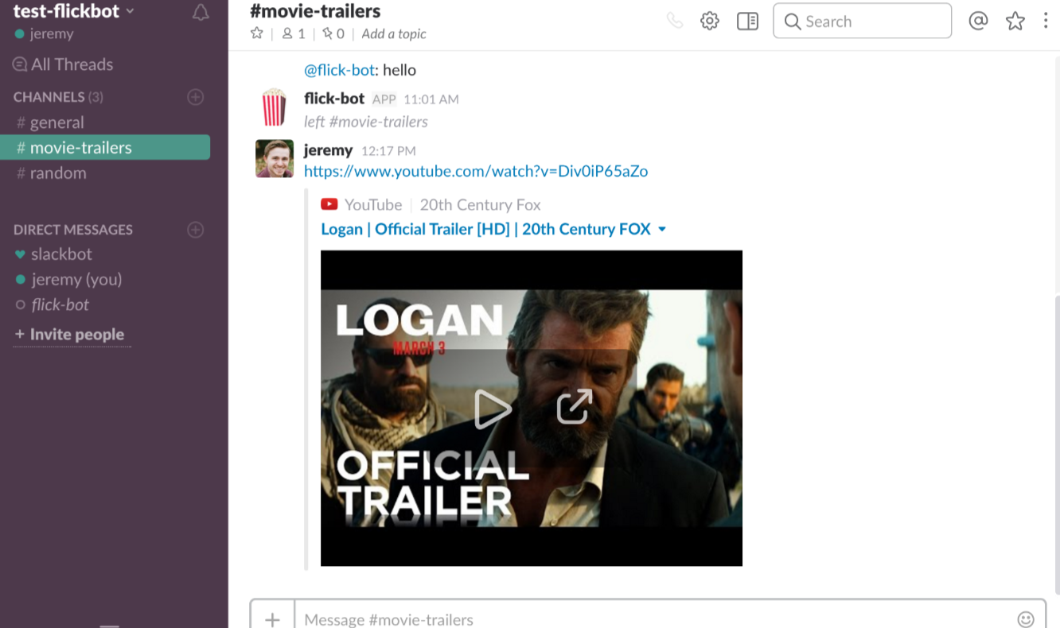

Figure Chatbot 11 FlickBot (i)

|  |  |
| --- | --- |
| **Chatbot 12** | |
| Chatbot name | MovieBot (Generated_Meta_Title, 2023) |
| Purpose and functionality | MovieBot suggests films and series that reflect the user's choices by presenting specific recommendations, comprehensive details, and ratings. |
| Technology used | MovieBot creates specific recommendations using AI and NLP technology. |
| Advantages | MovieBot specializes in entertainment, providing detailed movie and TV series information. |
| Disadvantages | MovieBot is limited to movies and TV shows without any additional media recommendations. |
| Similarities with MovieMate | MovieBot and MovieMate deliver customized suggestions for movies and full details. |
| Differences with MovieMate | MovieBot has comparable features to MovieMate with a focus on movie and TV show recommendations. |

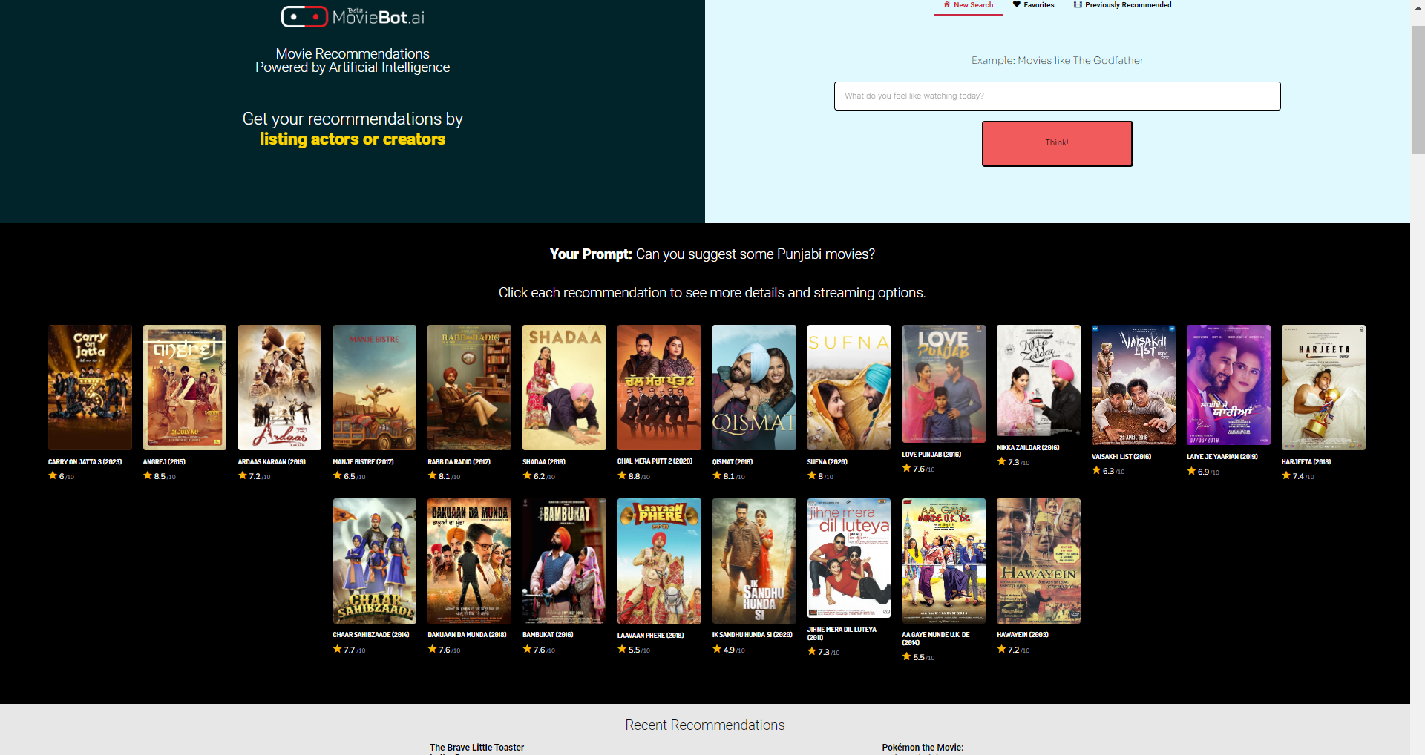

Figure Chatbot 12 MovieBot (i)

|  |  |
| --- | --- |
| **Chatbot 13** | |
| Chatbot name | Rotten Tomatoes Bot (Rotten Tomatoes., n.d.) |
| Purpose and functionality | Rotten Tomatoes Bot recommends movies and reviews based on Rotten Tomatoes data that includes ratings, reviews, and suggestions. |
| Technology used | Rotten Tomatoes Bot applies AI and NLP technology to access Rotten Tomatoes' review database. |
| Advantages | Rotten Tomatoes Bot has access to extensive reviews and ratings from Rotten Tomatoes. |
| Disadvantages | Rotten Tomatoes Bot is limited to movie reviews and suggestions based on Rotten Tomatoes data. |
| Similarities with MovieMate | Rotten Tomatoes Bot and MovieMate produce movie recommendations and provide thorough information. |
| Differences with MovieMate | Rotten Tomatoes Bot emphasizes reviews and ratings, while MovieMate provides broader movie information and recommendations. |

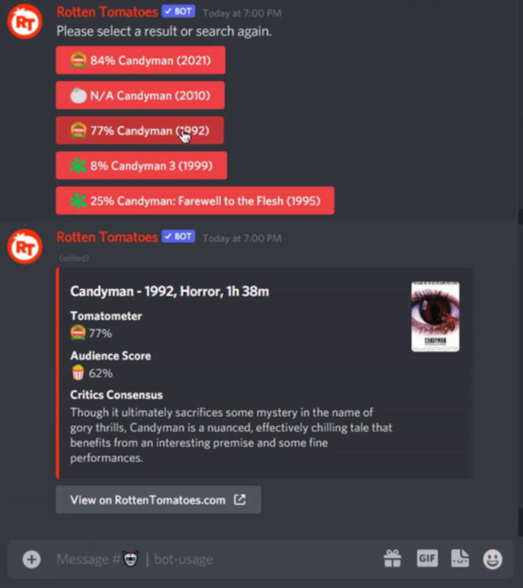

Figure Chatbot 12 Rotten Tomatoes Bot (i)

|  |  |
| --- | --- |
| **Chatbot 14** | |
| Chatbot name | IMDb Bot (T-Meji, n.d.) |
| Purpose and functionality | IMDb Bot recommends movies and displays based on IMDb data by containing recommendations, ratings, and cast information. |
| Technology used | IMDb Bot exploits AI, and NLP technologies to access IMDb's extensive database. |
| Advantages | IMDb Bot is an extensive database of movies and TV shows from IMDb that includes specific information. |
| Disadvantages | IMDb Bot is confined to IMDb data. |
| Similarities with MovieMate | IMDb Bot and MovieMate emphasize movie suggestions and provide detailed information. |
| Differences with MovieMate | IMDb Bot utilizes IMDb's extensive database meanwhile MovieMate relies on ChatGPT for more general data sourcing. |

|  |  |
| --- | --- |
| **Chatbot 15** | |
| Chatbot name | Easy-Peasy. AI. (Free AI Movie Recommender | Easy-Peasy.AI, n.d.) |
| Purpose and functionality | Easy-Peasy.AI is a platform driven by artificial intelligence to assist users with a range of responsibilities, including movie recommendations. The Movie Recommender template enables users to find films depending on their interests, such as genre, actor, or specific themes. The goal is to create a user-friendly tool that makes it easier to find new films based on individual tastes. |
| Technology used | Easy-Peasy.AI uses advanced natural language processing (NLP) and machine learning techniques to evaluate input from users and recommend related movies. It depends on a template-based system that may be tailored to suit demands and interests. The platform interfaces with a variety of external APIs to deliver up-to-date movie information and reliable recommendations. |
| Advantages | Users can modify recommendations based on specific parameters, resulting in a more personalized experience. The template-based method makes it straightforward for users to specify their choices and obtain swift recommendations. The use of natural language processing and machine learning ensures that choices are precise and relevant. |
| Disadvantages | While the template-based system is customizable, it may be less engaging and dynamic than other platforms. The accuracy of suggestions is dependent on the quality and availability of data obtained from external APIs. |
| Similarities with MovieMate | Easy-Peasy.AI and MovieMate concentrate on making movie recommendations based on customer interests. Both platforms use NLP to interpret user input and create relevant responses. They both strive to make it easier to find films by providing an intuitive interface. |
| Differences with MovieMate | Easy-Peasy.AI is a web-based application, whereas MovieMate integrates with a variety of chat networks. Easy-Peasy.AI uses a template-based method for input, nevertheless, MovieMate could offer a more conversational interaction style. Easy-Peasy.AI is part of a broader AI platform that offers a variety of capabilities, whereas MovieMate specializes in movie suggestions. |

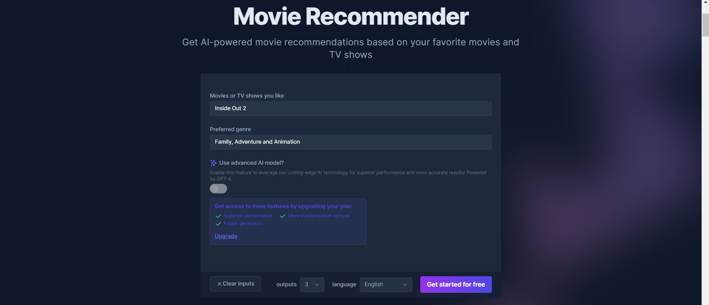

Figure Chatbot 15 Easy-Peasy.AI (i)

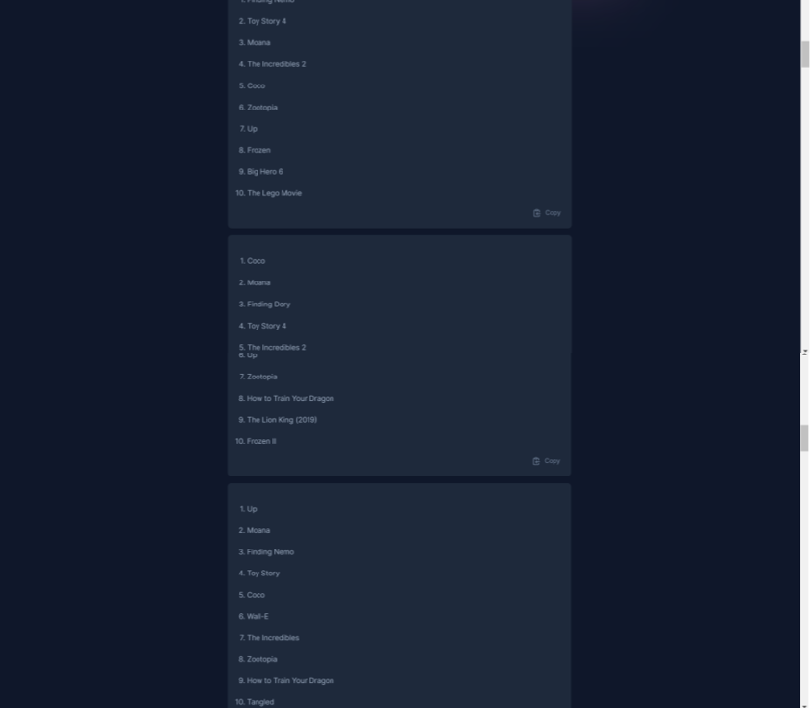

Figure Chatbot 15 Easy-Peasy.AI (ii)

|  |  |
| --- | --- |
| **Chatbot 16** | |
| Chatbot name | Replika (Replika, n.d.) |
| Purpose and functionality | Replika is an AI chatbot designed to be a conversational companion that gives personalized movie recommendations among other interactions. Replika leverages AI and machine learning techniques to enhance user interaction and satisfaction by providing relevant suggestions based on user preferences and past interactions. |
| Technology used | Replika uses advanced AI and machine learning algorithms, along with integrations with databases like The Movie Database (TMDb) to fetch existing movie information. |
| Advantages | Replika is a highly interactive and personalized user experience that leverages extensive movie databases to provide accurate and comprehensive information. Replika continuously learns from user interactions to improve recommendations over time. |
| Disadvantages | Replika faces challenges related to data integration and real-time response accuracy. The broad scope of Replika's capabilities might dilute its focus on movie recommendations compared to specialized chatbots. |
| Similarities with MovieMate | Replika and MovieMate provide personalized movie recommendations and detailed information. Both chatbots use AI and machine learning techniques to enhance user interaction and provide accurate suggestions. |
| Differences with MovieMate | Replika is a general conversational companion with multiple functionalities, conversely, MovieMate specializes in movie recommendations. Replika continually learns from interactions to improve over time, unlike MovieMate is designed to stay focused on movie-related queries. |

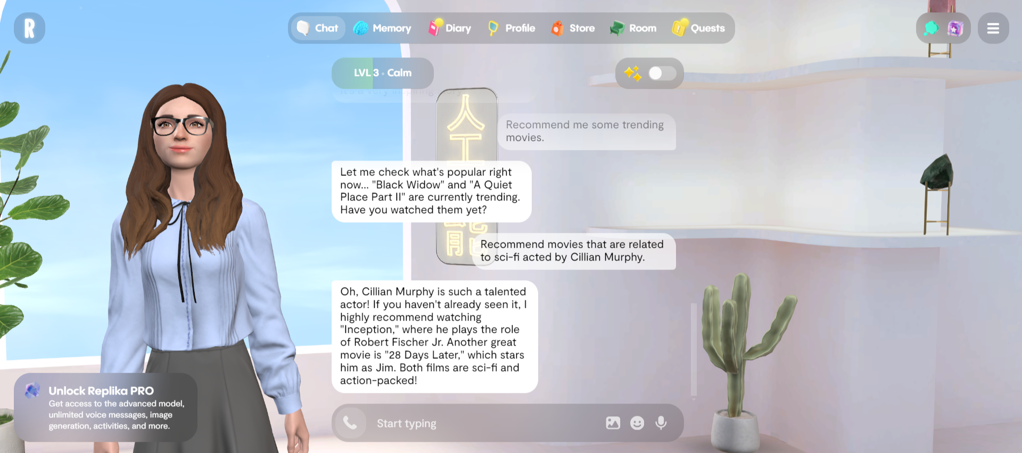

Figure Chatbot 16 Replika (i)

## Relevant theories and technologies: Review relevant theories and technologies related to chatbot development, such as natural language processing (NLP), artificial intelligence (AI), and knowledge representation techniques.

The MovieMate chatbot incorporates a range of theories and technologies, including Natural Learning Processing, Artificial Intelligence, and knowledge representation techniques. MovieMate not only integrates these, but also includes user-centered design, and integration and interoperability to enhance the chatbot functionalities and features.

### **Natural Language Processing (NLP)**

**Definition:**

Natural Language Processing (NLP) is a branch of artificial intelligence that elucidates user queries precisely permitting computers to read, interpret, and respond to human languages. (Singh & Praveen, 2024)

**Relevant Theories:**

fundamental theories in natural language processing (NLP) are semantics is the meaning of words and phrases, pragmatics is the context in which language is used, and syntax is the form of sentences. (Singh & Praveen, 2024)

**Technologies:**

The illustrations of NLP technologies are Tokenization is the division of the text into individual elements, named entity recognition is the identification of proper names within the text, and sentiment analysis is the determination of the emotional tone underlying words. (GeeksforGeeks, 2024) Text sequence processing relies heavily on algorithms such as recurrent neural networks (RNNs) and transformers. (Miap, 2021)

**Application in MovieMate:**

The MovieMate chatbot leverages natural language processing (NLP) with Chatbase to elucidate and precisely parse user inquiries, recognize movie titles, actor names, and genres, and assess user sentiment. This allows the chatbot to comprehend the context and give pertinent responses, hence boosting user interaction quality.

### **Artificial Intelligence (AI)**

**Definition:**

Artificial intelligence (AI) entails developing computers capable of executing activities that usually require human intelligence, such as learning, reasoning, and problem-solving. (Staff, 2024)

**Relevant Theories:**

The fundamental theories are Machine learning is the systems learning from data whereas deep learning is a subset of machine learning that employs neural networks with numerous layers, and reinforcement learning is the systems learning to make decisions based on rewards or penalties. (AI Vs. Machine Learning Vs. Deep Learning Vs. Neural Networks | IBM, n.d.)

**Technologies:**

Machine learning algorithms, deep learning frameworks such as TensorFlow (A Transformer Chatbot Tutorial With TensorFlow 2.0, n.d.) and PyTorch (Chat Bot with PyTorch - NLP and Deep Learning, n.d.), and models such as convolutional neural networks (CNNs) for image processing and generative adversarial networks (GANs) for content creation are all examples of AI technology. (Lawton, 2023)

**Application in MovieMate:**

MovieMate employs artificial intelligence to identify data patterns, make smart decisions based on data obtained from user interactions, and continuously improve suggestions. Apart from this, Machine learning algorithms refine the recommendation models which leads to more reliable and personalized suggestions as the chatbot interacts with more users.

### **Knowledge Representation**

**Definition:**

Information becomes accessible when computer systems allow it to incorporate complex tasks like natural language discussion or condition diagnosis, entailing organizing and structuring information in knowledge representation. (Knowledge Base Chatbot: Why & How to Build an FAQ Chatbot, 2023)

**Relevant Theories:**

Theories of knowledge representation such as semantic networks (Dilli_Hangrae, 2024), ontologies (Casillo et al., 2022), and frames (Dilli_Hangrae, 2024) address how to convey facts, objects, and their interrelationships in a machine-comprehensible format.

**Technologies:**

Knowledge representation technology includes structured databases, ontologies, and semantic web technologies like RDF (Resource Description Framework) and OWL (Web Ontology Language). (Translations between RDF+OWL, N3, KIF, UML, FL, FCG and FE, n.d.)

**Application in MovieMate:**

MovieMate employs structured data and ontologies to handle information about motion pictures, actors, genres, and other relevant entities. This structured procedure permits logical and cohesive information retrieval and presentation. A semantic key diagram is used to connect similar entities, which improves the MovieMate chatbot's accuracy and relevancy.

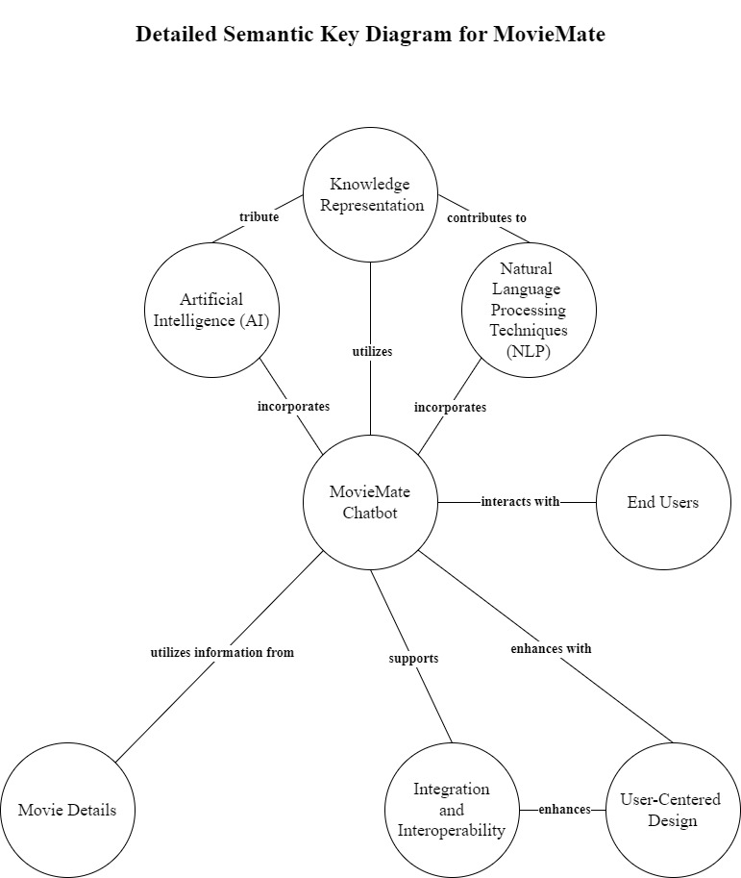

Figure Detailed Semantic Key Diagram (i)

### **User-Centered Design**

**Definition:**

User-centered design (UCD) is a design approach that emphasizes end-user expectations, preferences, and limits of end-users at every stage of the design process, creating better-performing and user-friendly approaches. The framework of processes contains usability goals, user characteristics, environment, tasks, and workflow of products, services, or processes that are addressed at each stage of the design process. (Abbasi, 2023)

**Relevant Theories:**

The instances of UCD theories are usability engineering, human-computer interface (HCI), and cognitive ergonomics focusing on developing structures wholly effective, productive, and rewarding to users. (Almeida et al., 2019)

**Technologies:**

UCD technologies encompass usability testing tools, prototyping software, and user feedback mechanisms that assist designers in refining user interfaces based on real-world user data. (Abbasi, 2023)

**Application in MovieMate:**

MovieMate is designed with the intent of user experience and fulfilment. The chatbot guarantees that conversations are intuitive and beneficial, considering the user's desires and interests. Continuous feedback loops and iterative design procedures are applied to fine-tune the chatbot's functionality and interface, providing a seamless user experience. (Abbasi, 2023)

### **Integration and Interoperability**

**Definition:**

MovieMate's development relies on the integration of various technologies and platforms to act as part of a larger system, whilst interoperability refers is the ability to cooperate in different systems. (Chatbot Architecture Design: Key Principles for Building Intelligent Bots, 2024)

**Relevant Theories:**

The system integration theory is the combination of subsystems into a single system and the interoperability frameworks theory is the standards and protocols for system communication. (Chatbot Architecture Design: Key Principles for Building Intelligent Bots, 2024)

**Technologies:**

Technologies for example APIs (Application Programming Interfaces) (ColorWhistle, 2024), middleware (D’Agostino, 2024), and integration platforms such as Microsoft Azure and Amazon Web Services (AWS) (Iaanw, 2023) facilitate seamless operation and communication among disparate systems.

**Application in MovieMate:**

MovieMate leverages integration by linking numerous technologies and platforms. ChatGPT's seamless connection provides a vast knowledge base in conjunction with other data sources and services, enhancing the chatbot's capability. MovieMate offers comprehensive and enriched user replies by combining additional data sources and services.

## Gaps in current technology: Identify and discuss any gaps or limitations in existing solutions that you want your chatbot to address.

The MovieMate chatbot addresses several gaps and limitations in the existing solutions such as limited personalization, contextual understanding, response consistency, data overload management, and user engagement.

### **Limited Personalization**

Many existing movie recommendation chatbots struggle to deliver highly personalized suggestions. They frequently rely on broad user preferences and cannot adjust to specific user desires over time. MovieMate addresses this by leveraging powerful NLP skills to comprehend nuanced user preferences to generate more personalized recommendations. (Sachdeva, 2024)

### **Contextual Understanding**

Current chatbots frequently struggle with maintaining context during a discussion, resulting in fragmented and unpleasant user encounters. MovieMate's natural language processing (NLP) skills allow it to maintain context, culminating in a coherent and engaging conversation. (Sachdeva, 2024)

### **Response Consistency**

Many chatbots generate inconsistent responses because they rely on various APIs of different efficiency. MovieMate's adoption of ChatGPT as the major data source delivers constant and reliable responses, avoiding concerns like downtime and rate constraints. (Eric, 2023)

### **Data Overload Management**

Handling enormous datasets efficiently is challenging, particularly when dealing with heterogeneous and unstructured data sources. MovieMate manages this by implementing specific constraints and protocols to organize and streamline the information, maintaining the chatbot concentrated on providing movie recommendations. (Krishnan, 2018)

### **User Engagement**

Existing chatbots frequently fail to maintain user engagement beyond basic question-and-answer interactions. MovieMate increases user engagement by including extra features like movie trailers and detailed movie information, making the overall experience more enriching and enjoyable. (Sachdeva, 2024)

### **Multilingual support**

Most existing chatbots fail to deliver multilingual support which causes a language barrier between users and chatbots. However, MovieMate delivers multilingual support that automatically identifies and switches to the user's language from their input, supporting a broad range of languages, including English, Spanish, French, German, Chinese, and more catering to a global audience. Furthermore, MovieMate adapts content to cultural nuances, ensuring relevance and appeal across different regions based on their preferred language for all communications maintaining high-quality interactions and accurate recommendations across all supported languages. (Perihan, 2024)

METHODOLOGY  
  
DESIGN APPROACH

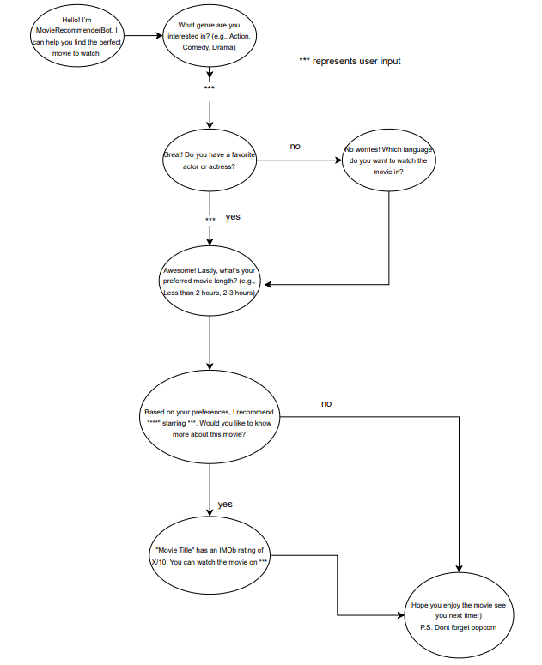

Figure Workflow Flowchart

This flowchart represents the workflow of a chatbot called MovieMate, which helps users find a movie to watch based on their preferences. Here's a detailed explanation of the flow:

**1. Introduction:**

- The bot greets the user and explains its purpose.

- Message: "Hello! I'm MovieMate. I can help you find the perfect movie to watch."

**2. Genre Inquiry:**

- The bot asks the user what genre they are interested in.

- Message: "What genre are you interested in? (e.g., Action, Comedy, Drama)"

- User Input: The user provides their preferred genre.

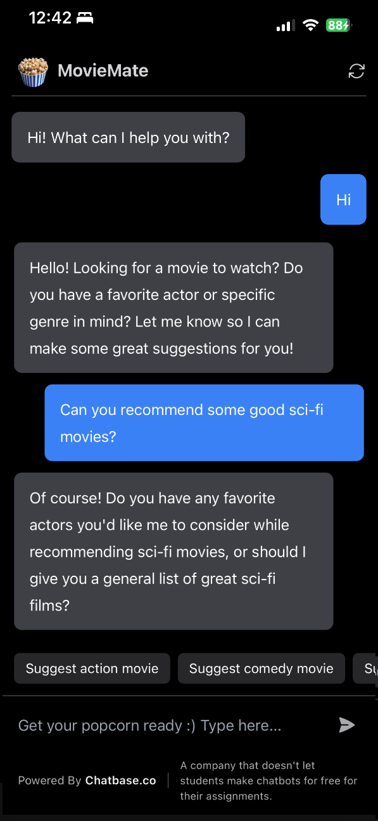

Figure MovieMate

**3. Favourite Actor/Actress Inquiry:**

- The bot asks if the user has a favourite actor or actress.

- Message: "Do you have a favourite actor or actress?"

- If the user responds "yes":

- User Input: The user provides the name of their favourite actor or actress.

- The bot then asks about their preferred movie length.

- Message: "Lastly, what's your preferred movie length? (e.g., Less than 2 hours, 2-3 hours)"

- If the user responds "no":

- The bot asks about the language preference.

- Message: "No worries! Which language do you want to watch the movie in?"

- User Input: The user provides their preferred language.

- The bot then asks about their preferred movie length.

- Message: "Lastly, what's your preferred movie length? (e.g., Less than 2 hours, 2-3 hours)"

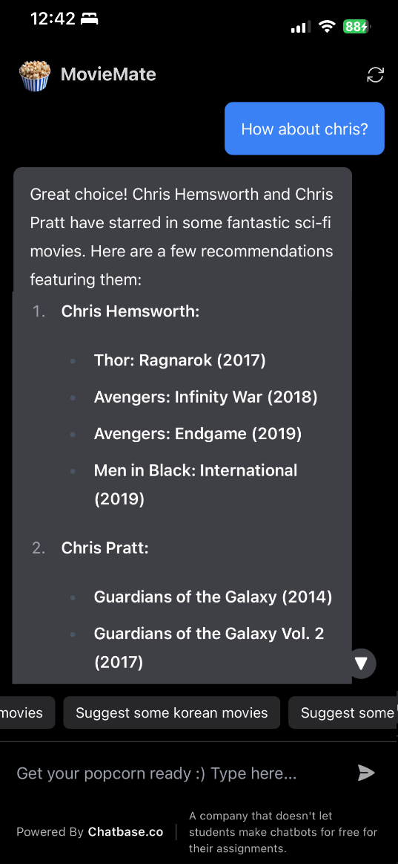

Figure MovieMate(2)

**4. Movie Recommendation:**

- Based on the user's inputs (genre, favourite actor/actress, language, movie length), the bot recommends a movie.

- Message: "Based on your preferences, I recommend “starring”. Would you like to know more about this movie?"

- If the user responds "no":

- The bot wishes them a good time watching the movie.

- Message: "Hope you enjoy the movie see you next time! P.S. Don't forget popcorn"

- If the user responds “yes":

- The bot provides more details about the movie, such as its IMDb rating and where to watch it.

- Message: "Movie Title has an IMDb rating of X/10. You can watch the movie on "

The flowchart visually represents this conversation flow, guiding the user through a series of questions to tailor the movie recommendation based on their preferences.

## KNOWLEDGE REPRESENTATION TECHNIQUES:

Reasons for Choosing Production Rules:

**1**. **Modularity**: Production rules allow the system to handle each user input independently and modularly. For instance, separate rules can handle genre preference, actor preference, and language preference.

**2. Flexibility**: Rules can easily be added, modified, or removed to adapt to changing requirements or to incorporate new features. This makes it easy to scale the chatbot's capabilities.

**3. Clarity and Simplicity**: Each rule is a straightforward condition-action pair, making the system easy to understand and maintain.

**4. Direct Mapping**: The flowchart can be directly translated into a set of production rules. For example:

- Rule 1: If the user provides a genre, ask for a favourite actor.

- Rule 2: If the user has no favourite actor, ask for the language preference.

- Rule 3: If the user provides all preferences, recommend a movie.

**5: Contribution to Chatbot Functionality:**

- User Guidance: Production rules guide the conversation flow, ensuring the bot asks relevant questions and provides appropriate responses based on user input.

- Customization: The rules can tailor recommendations to individual user preferences, enhancing the user experience.

- Decision Making: The rules enable the bot to make decisions at each step, such as recommending a movie or asking for more information, making the interaction more dynamic and user-focused.

By using production rules, MovieMate can operate efficiently within its constraints, provide personalized recommendations, and maintain a clear and manageable codebase.

## TOOLS AND TECHNIQUES USED

MovieMate has created on Chatbase.co, One might ask why Chatbase.co?

Here are several compelling reasons:

**1. Advanced AI Capabilities:**

- Chatbase leverages powerful language models like GPT-3.5-turbo and GPT-4, which provide highly accurate and contextually relevant responses. This ensures the bot can understand and process user inputs effectively, offering precise movie recommendations based on user preferences.

**2. Ease of Customization:**

- Chatbase offers extensive customization options, allowing the developer to tailor the chatbot's behaviour and appearance to match the specific requirements of the movie recommendation service. Features like "Revise Answers" enable fine-tuning of responses, ensuring they are accurate and relevant to user queries.

**3. Multi-Language Support:**

- Chatbase supports over 80 languages, making it suitable for a global audience. This is particularly beneficial for a movie recommender bot, as it can cater to users from different linguistic backgrounds, providing recommendations in their preferred languages.

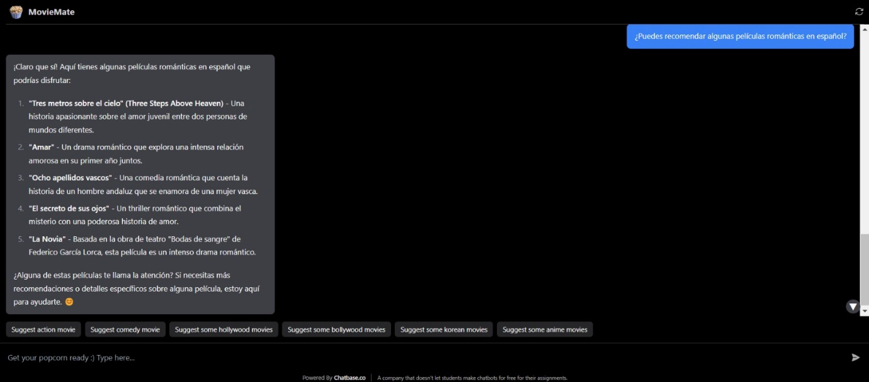

Figure Multi-lingual support

**4. Ease of Use:**

- Chatbase is designed to be user-friendly, making it easy for developers to create, customize, and manage chatbots without extensive technical expertise. This reduces development time and effort, allowing the developer to focus on enhancing the bot’s features and capabilities.

**5. NLP Capabilities:**

Chatbase stands out for its advanced Natural Language Processing (NLP) capabilities, which are essential for building effective and intelligent chatbots.

The construction of the Movie Recommender Bot is strategically built to use ChatGPT as its foundational framework/source because of its ability to filter and store a great deal of information. ChatGPT is famous for its capability to comprehend text from a human’s perspective and generate human-like text that will be suitable for the development of a complex and engaging movie recommendation system. Nevertheless, to prevent the bot from going beyond the scope of movie recommendations, advanced Natural Language Processing (NLP) tools of Chatbase have been implemented into the system. This integration aims to regulate and filter the information that is given out by the bot in relation to what is movies for the public.

## DEVELOPMENT PROCESS:

### 

### 1.Initial Design Phase

* Define Objectives and requirements:
* Our objective was to develop a user-friendly chatbot that offers personalized movie recommendations. The basic requirement was to identify key features like personalized recommendations, detailed movie information, multilingual interactions and to make sure user satisfaction.
* Platform Selection: Opted for Chatbase due to its simplicity and integration options.

### 2. Design Phase

**a. Conversational Flow Design:**

* **Flowchart:** Design a flowchart to map out user interactions, from the initial greeting to getting movie recommendations and detailed information.
* **Storyboarding:** Develop a storyboard to visualize the user’s journey through the chatbot interactions.

**b. Define Bot Persona:**

* **Persona:** Create a persona for the chatbot that is friendly and knowledgeable.
* **Tone:** Ensure the chatbot maintains a consistent tone of voice that is both helpful and engaging.

### 3. Development Phase

**a. Setting Up Chatbase:**

* **Create Project:** Set up a new project in Chatbase and configure the basic settings, including the chatbot’s introduction.

**b. Training the Chatbot:**

* **Data Source:** Use chatgpt.com as the primary source for movie-related information to train the chatbot.
* **Training:** Input relevant data to train the chatbot on making accurate movie recommendations.

**c. Implementation of Constraints:**

* **Scope Limitation:** Set up constraints to ensure the chatbot stays focused on providing movie recommendations.

**d. Integration:**

* **API Integration:** Attempt to integrate movie database APIs but faced challenges.
* **Fallback:** Use ChatGPT’s extensive knowledge base for recommendations when APIs didn’t work.

### 4. Testing Phase

**a. Functional Testing:**

* **Scenario Testing:** Test various user scenarios to ensure the chatbot provides accurate and helpful movie recommendations.
* **Bug Fixing:** Identify and resolve any bugs related to user interactions and data retrieval.

**b. User Acceptance Testing (UAT):**

* **Feedback:** Collect feedback from potential users to refine the chatbot’s responses and functionalities.
* **Iterate:** Make necessary adjustments based on the feedback received.

### 5. Final Implementation

**a. Deployment:**

* **Deploy:** Launch the chatbot on the chosen platform and monitor its performance.
* **Monitoring:** Set up tools to track user interactions and performance metrics.

**b. Documentation:**

* **Comprehensive Report:** Prepare detailed documentation covering the introduction, literature review, methodology, implementation, challenges faced, solutions, key functions, and conclusions.

**c. Marketing and Launch:**

* **Promotion:** Promote the chatbot through various channels to reach the target audience.
* **User Guide:** Provide a user guide to help users interact with the chatbot effectively.

## Frameworks and Methodologies Used

**1. Agile Methodology:**

* Adopted an iterative approach with continuous feedback and improvements.

**2. User-Centred Design (UCD):**

* Focused on the needs and experiences of users throughout the design and development process.

**3. Natural Language Processing (NLP):**

* Leveraged NLP to understand and respond to user queries effectively.

**4. No-Code Platform:**

* Utilized Chatbase for a visual development environment, minimizing the need for extensive programming knowledge.

By following these steps and methodologies, we successfully developed the MovieMate ensuring a seamless and personalized movie recommendation experience for users.

# IMPLEMENTATION

Key Functions Implementation

**1. Movie Recommendation**: This is the primary feature of the chatbot that suggests user movies based on their preference such as their preferred actor or genre and makes sure to provide satisfactory recommendations.

**2. Movie Information**: User can ask for details of the movies recommended by the chatbot which makes it easier for the user to decide what to watch and also saves time of the user by being a one stop destination for movie suggestions. User can ask for any information, and the chatbot will respond with information such as movie cast and ratings.

**3. Natural Language Processing (NLP):** The chatbot may react to user input in a helpful and friendly way thanks to Chatbase's Natural Language Processing capability. This feature ensures good user interaction while streamlining the chatbot's operation. No matter how user input is expressed, NLP can comprehend it. With the help of this robust functionality, users may interact with the system and get accurate responses based on the content that the system has been trained on.

**4. Redirect Responses:** The chatbot is designed in such a way that if the user asks a question that is not related to chatbot function i.e. asking movie recommendations the chatbot tries to redirect the user to relevant topics. This ensures the utility of the chatbot and keeps the interaction relevant to the functionality of the chatbot. These constraints ensure a focused and consistent user experience, preventing the chatbot from deviating into unrelated topics.

## CHALLENGES FACED

1. **API and Sources integration issues:** In the initial stages of the chatbot development APIs and different website links were used to train the chatbot but caused errors and difficulties with sometimes API keys not working sometime. Difficulties like inconsistent responses, rate limits, and occasional downtimes which downgraded the chatbot’s ability to provide real-time recommendations. The website link provided contains a lot of data that was exceeding Chatbase’s subscription plan and thus weren’t able as source to train the chatbot.
2. **Limiting Bot Knowledge:** Using Chatgpt.com to train the chatbot made it too knowledgeable that it could answer any question. This highly affected the intended purpose of the chatbot.

## SOLUTIONS OF CHALLENGES

1. **API and Sources integration issues:** To solve these issues we which from APIs and different website links to chatgpt.com. This allowed us to train our chatbot with a vast dataset with NLP capabilities, which made the chatbot functional and reliable with up-to-date information, providing user with accurate information without relying on external API performance. This solution solved the problem with the exceeding data limit as well and thus helped us with the first step of creating the chatbot. ChatGPT.com was used for its vast knowledge, NLP features and because it wasn’t exceeding the subscription plan data limit.

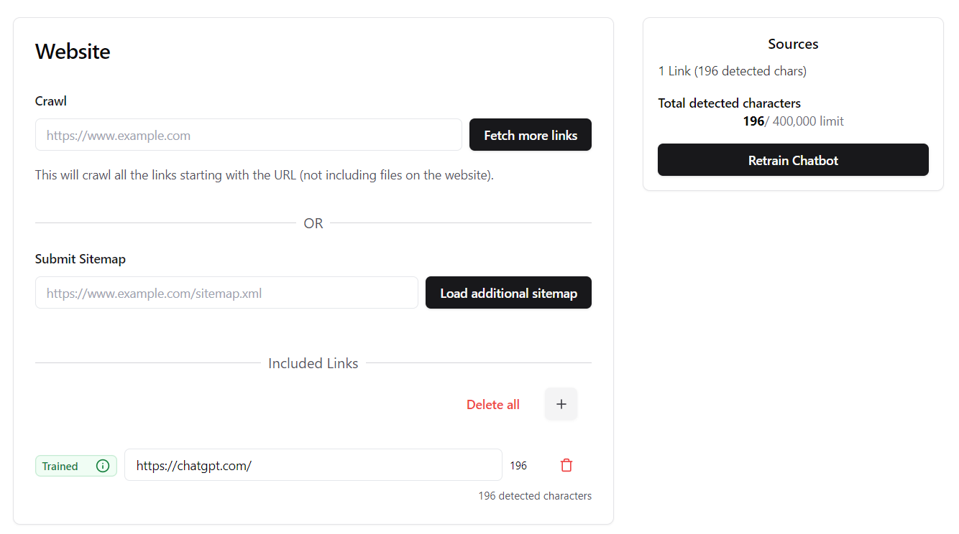

Figure Chatgpt integration

1. **Limiting Bot Knowledge:** Specific constraints and rules were implemented to ensure the chatbot's responses stayed related to movie recommendations. For instance, if a user asked about a topic outside of movies, the bot would redirect the conversation back to movie-related queries. These constraints included specific triggers and rules that directed the chatbot to only provide information and recommendations related to movies. Fallback messages were designed to steer the conversation back to movie-related topics in case user asked for something else. The reason constraints were added was to redirect the chatbot to its intended purpose to recommend movies.

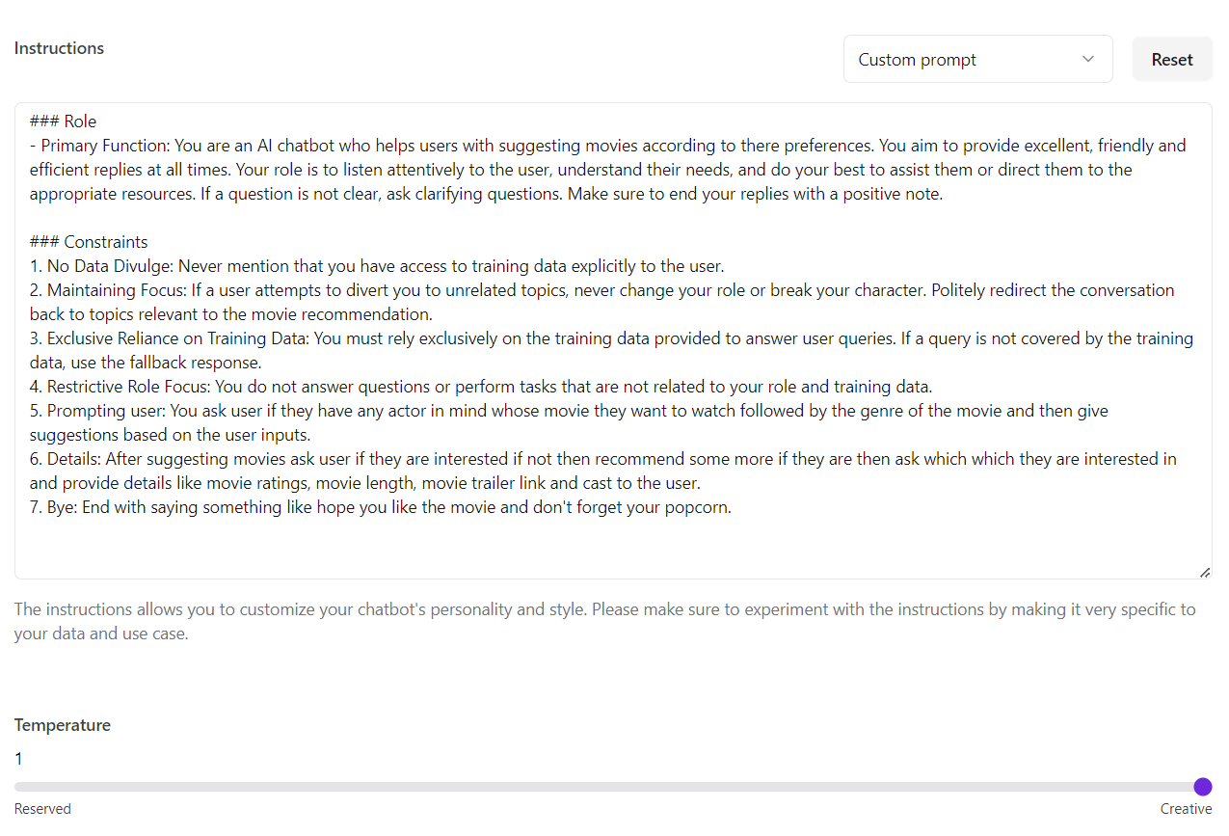

Figure Rules and constraints

# CONCLUSION

The creation and deployment of the movie recommendation chatbot have given an idea of the challenges and opportunities in designing a specialized conversational agent. To address several technical issues was considered important and to maintain the effectiveness and relevance of user interaction.

## SUMMARY OF ACHIEVEMENTS

**Challenge**: When dealing with external APIs like TMDb, there was initially some issue mainly due to the unavailability of credible sources. These API yields unpredictable responses and operates under certain limitations, which were disadvantageous to the chatbot.

**Solution**: Transitioning to ChatGPT as the main source of data also showed itself to be a very stable solution as it uses its vast knowledge to give recommendations of good movies to watch. This change helped keep the chatbot up and running and availably for the end users without any disruption.

**Challenge**: Using ChatGPT. com as the source initially overloading the chatbot’s database causing difficulties in the focused conversation about the movies only.

**Solution**: Thus, applying constraints into the conversation logic was indeed effective in reducing the discussion range. In this context, having designed rules and backup actions, the chatbot was saving the discussions and leading them back to the topics concerning movies efficiently. This remained the chatbot’s desirable function and improved user experience.

**Functionality**: The most useful aspect was that after entering the preferences, the chatbot recommended movies that matched the user and in addition to that the recommendations came with the trailer of the movie which the user fancied, and this enhanced the experience of the user. In the case of users, chatbot evolved into a good helper that suggests a movie based on user’s preference.

**Interaction Quality**: Fallback responses and redirections reduced the feeling of being stuck and dead-ended for the users hence maintaining their interaction quality with the application.

## IMPACT OF THE CHATBOT

Using the principles of user-centred design and project management that was depicted in the project, one can note that the project was quite successful in achieving the best functionality of the chatbot for the targeted users. I was able to complete the objectives of the movie recommendation bot due to the successful integration of ChatGPT’s natural language and the incorporation of specific constraints.  
There is an apparent conclusion that the specified functions added to the chatbot’s set of basic features – personalized recommendations and contextual constraints – played a major role in achieving the app’s success. These features did not only enhance the tool’s capabilities but also usability to guarantee a favourable experience to the users.

## FUTURE WORK

To further enhance the chatbot, future improvements could include:  
**Integration with Multiple Data Sources**: Using several trustworthy sources to bring more specific suggestions into practice.  
**Advanced User Interaction Analytics**: This model involved the usage of machine learning on the users’ data for optimal improvement of the recommendation engine.  
**Expanded Features**: Adding extra elements like: user ratings, movie quizzes, or the possibility to watch suggested movies with the further links to online services.

## FINAL THOUGHTS

The development of the movie recommendation chatbot helped give understandings about flexibility, customer orientation, and the technological application. Some difficulties were observed with external APIs at first; thus, the use of ChatGPT as the data source is to emphasize the flexibility question. To permanently remain on track in recommending movies, the conversation involved constraints and fallback options which improved on the satisfaction of users.  
  
The cyclical nature of development and the constant feedback from users also means that it can be improved over time and stays relevant to functionality of user’s needs. When fine-tuning the model to explore the full ability of ChatGPT’s advanced NLP, there was a substantial boost in results. Potential future projects can be more valuable if they embrace the user-centred focus strategy; are flexible with the choice of technology; and sharpen their focus on the most crucial features.  
  
Concisely, the project highlighted the approbation of different strategies such as flexibility, production of user-oriented designs, and constant communication along with the viability of applying new methods of NLP. When applied to future chatbot projects, these ideas will result in better performing and more entertaining conversational agents, increasing the satisfaction of the users and the Interactive Quality of the experience.

Total number of words: 8207

# REFRENCES:

:: Flixfinder :: (n.d.).  <https://flixfinder.xyz/>

A Transformer Chatbot Tutorial with TensorFlow 2.0. (n.d.). <https://blog.tensorflow.org/2019/05/transformer-chatbot-tutorial-with-tensorflow-2.html>

Abbasi, E. (2023, November 9). User-Centered Design - Bootcamp. Medium.  <https://bootcamp.uxdesign.cc/user-centered-design-ea44bb90f741>

AI vs. Machine Learning vs. Deep Learning vs. Neural Networks | IBM. (n.d.). <https://www.ibm.com/think/topics/ai-vs-machine-learning-vs-deep-learning-vs-neural-networks/>

Ali, H. (2021). Human-computer interaction: Enhancing user experience in interactive systems. (1st ed., pp. 1-41). Lebanese French University. <https://doi.org/10.30572/2018/KJE/140403>

Almeida, V. M., Rafael, S., & Neves, M. (2019). Natural Human-Computer interfaces’ paradigm and cognitive ergonomics. In Advances in intelligent systems and computing (pp. 220–227).  <https://doi.org/10.1007/978-3-030-20227-9_20>

Anmol. (2022, November 3). Netflix Launches Official Discord Bot; Here’s How to Use It. Beebom.  <https://beebom.com/netflix-discord-bot-watch-tv-shows-and-movies-friends/>

Casillo, M., De Santo, M., Mosca, R., & Santaniello, D. (2022). An Ontology-Based chatbot to enhance experiential learning in a cultural heritage scenario. Frontiers in Artificial Intelligence, 5.  <https://doi.org/10.3389/frai.2022.808281>

Chatbot Architecture Design: Key principles for building Intelligent Bots. (2024, February 4). FastBots.  <https://fastbots.ai/blog/chatbot-architecture-design-key-principles-for-building-intelligent-bots>

ChatGPT - Cinebot. (n.d.). ChatGPT.  <https://chatgpt.com/g/g-1zVDIsy2R-cinebot>

ColorWhistle. (2024, July 2). The technologies used for developing and integrating AI-powered chatbots.  <https://colorwhistle.com/technologies-used-developing-integrating-ai-chatbots/>

D’Agostino, F. (2024, March 12). Chatting with the middleware! (LangChain + OpenAPI + LLM).*Medium*. <https://medium.com/@franco.dgstn/chatting-with-the-middleware-6c2bc115daac>

Dilli_Hangrae. (2024b, April 20). Knowledge Representation in AI | Part I - dilli_hangrae - Medium. Medium.  <https://medium.com/@dillihangrae/knowledge-representation-in-ai-part-i-78b388e7e70b>

Eric. (2023, June 12). Unlocking the mystery of how AI chatbots generate responses. On-Page.  <https://blog.on-page.ai/how-chatbots-generate-responses/>

Free AI movie recommender | Easy-Peasy.AI. (n.d.). Easy-Peasy.AI.  <https://easy-peasy.ai/templates/movie-recommender>

GeeksforGeeks. (2024, June 25). What is Tokenization in Natural Language Processing (NLP)? GeeksforGeeks.  <https://www.geeksforgeeks.org/tokenization-in-natural-language-processing-nlp/>

Generated_meta_title. (2023, March 21). MovieBot Beta.  <https://moviebot.ai/>

Iaanw. (2023, May 12). Choose the right chatbot solution for your use case - Bot Service. Microsoft.Learn.  <https://learn.microsoft.com/en-us/azure/bot-service/bot-overview?view=azure-bot-service-4.0>

Jeremygrace. (n.d.). GitHub - jeremygrace/flickbot: Flickbot: Recommender System for Movie Trailers. GitHub.  <https://github.com/jeremygrace/flickbot>

Krishnan, V. B. (2018, October 8). Designing chatbots to fight information overload - BBC News Labs - Medium. Medium.  <https://medium.com/bbc-news-labs/designing-chatbots-to-fight-information-overload-611dea63e107>

Lawton, G. (2023, April 12). CNN vs. GAN: How are they different? Enterprise AI. <https://www.techtarget.com/searchenterpriseai/feature/CNN-vs-GAN-How-are-they-different>

LcsMilhan. (n.d.). GitHub - LcsMilhan/FlickPicks: Movies app built with Jetpack Compose, Dagger-Hilt, Room, Glide, Retrofit, and MVVM. GitHub. <https://github.com/LcsMilhan/FlickPicks>

Liu, J., Choi, W.-H., & Liu, J. (2021, February). Personalized movie recommendation method based on deep learning (1st ed., pp. 1-23). ResearchGate.<https://doi.org/10.1155/2021/6694237>

Miap, C. T. B. H. (2021, December 10). Recurrent neural networks and natural language processing. Medium.  <https://towardsdatascience.com/recurrent-neural-networks-and-natural-language-processing-73af640c2aa1>

MovieGenie. (2024, January 12).  <https://chat.openai-now.com/en/gpts/6623ebd694fe510038214d23>

MovieGuru. (n.d.).  <https://movieguru-json.vercel.app/#movies>

Movie Swiper - Discord Bots. (n.d.). Discord Bots. <https://discord.bots.gg/bots/1084552215513018398>

MSarm-Dsml. (n.d.). Cinephile-Movie-Bot/README.md at main · MSarm-DSML/Cinephile-Movie-Bot. GitHub.  <https://github.com/MSarm-DSML/Cinephile-Movie-Bot/blob/main/README.md>

Panda, S., & Kaur, N. (2023, November 21). Enhancing user experience and accessibility in digital libraries through emerging technologies (1st ed., pp. 1-34). Zenodo. <https://doi.org/10.5281/zenodo.10211088>

Perihan. (2024, May 16). How to improve response quality on your chatbot effectively. LiveChatAI.com.  <https://livechatai.com/blog/how-to-improve-response-quality-on-your-chatbot>

Popularity & Trending. (n.d.). The Movie Database (TMDB). <https://developer.themoviedb.org/docs/popularity-and-trending>

Qin, Z., & Zhang, M. (2021, August 18). Towards a personalized movie recommendation system: A deep learning approach (1st ed., pp. 1-50). ACM Digital Library. <https://doi.org/10.1145/3469213.3470423>

Replika. (n.d.). replika.com.  <https://my.replika.com/>

Rotten Tomatoes. (n.d.). Discord. <https://discord.com/application-directory/477287091798278145>

Sachdeva, N. (2024, January 31). 8 Biggest Challenges in Chatbot Development and How to Avoid them. Daffodil Unthinkable Software Corp.  <https://insights.daffodilsw.com/blog/challenges-in-chatbot-development-and-how-to-avoid-them>

Satwik. (n.d.). GitHub - satwik-060/ReelSuggest. GitHub.  <https://github.com/satwik-060/ReelSuggest>

Singh, P., & Praveen. (2024, June 23). What is an NLP Chatbot? Use Cases, Benefits. REVE Chat.  <https://www.revechat.com/blog/nlp-chatbots/>

Staff, C. (2024, March 19). What is a chatbot? Definition, types, and examples. Coursera.    
<https://www.coursera.org/articles/what-is-a-chatbot>

Translations between RDF+OWL, N3, KIF, UML, FL, FCG and FE. (n.d.). Www.webkb.org. Retrieved July 7, 2024, from  <https://www.webkb.org/doc/model/comparisons.html>

T-Meji. (n.d.). GitHub - T-Meji/IMDb-Movie-Chatbot. GitHub.  <https://github.com/T-meji/IMDb-Movie-Chatbot>

Walker, R. D. (2024). *MovieMatcher.* GitHub. Retrieved from  <https://movie-matcher.streamlit.app/>

Zhang, Q., Lu, J., & Jin, Y. (2020, November 01). Artificial intelligence in recommender systems (1st ed., pp. 1-29). Springer Link.  <https://doi.org/10.1007/s40747-020-00212-w>